First steps to financial inclusion

Opportunities to promote inclusive customer onboarding

25 March 2025

Accessible Format

Contents
Foreword 3
Executive Summary 5
Section One: Background 8
Section Two: Purpose and Approach 11
Section Three: Analysis of results 13
Experiences with opening bank accounts 14
Customer onboarding practices 18
Impacted customer segments 23
Māori perspectives 32
Enablers of inclusion 35
Section Four: Conclusions and next steps 40
The problem 42
Underlying drivers 44
Actions and next steps 44
Annex: Glossary 48
Appendix 1: Research methodology …………………………………………………………………………………………………………………….55
Appendix 2: Research questions …………………………………………………………………………………………………………………….62

About the title
Bank accounts are a vital product for people to participate in the financial system and often a prerequisite for people to get a job, receive an income, or make payments. The process of opening a bank account is often an entry point for people to establish a relationship with a financial provider and take on more complex products and services over time (such as savings and insurance). As a result, the onboarding process to open a bank account is often a first step to broader financial inclusion.

Acknowledgements
This is a joint report that has been developed by ThinkPlace New Zealand and the Reserve Bank of New Zealand - Te Pūtea Matua (RBNZ). The research methodology was designed and carried out by ThinkPlace New Zealand, and the report was co-authored by ThinkPlace New Zealand and RBNZ, and socialised with the Council of Financial Regulators to gather feedback from peer regulators.
We would like to acknowledge the people and organisations who participated in this research on a voluntary basis and their willingness to share their experiences and suggest improvements to accessing banking and customer onboarding.

Disclaimer and limitations
The perspectives provided are the free and frank views of frontline banking staff and customers, independent of their organisations and employers. Efforts were taken to reflect a diverse range of perspectives in this research, however there are many other experiences that we did not hear about. We have not undertaken statistical analysis or extrapolated these findings to consider whether they are representative across broader populations beyond those who directly participated in the research. This research does not constitute formal regulatory guidance.

Foreword
Supporting financial inclusion is essential for New Zealanders to fully engage with our financial system.
Financial inclusion enables people to manage their money, build confidence, and participate in economic life. Financial inclusion contributes to RBNZ’s purpose to promote the prosperity and well-being of New Zealanders and contribute to a sustainable and productive economy.
At RBNZ, an inclusive financial system means that all New Zealanders can reasonably access financial services and products that meet their needs. Financial inclusion has been reflected in the Deposit Takers Act 2023 (which has a secondary purpose to promote reasonable access to financial products and services), the Minister of Finance’s Financial Policy Remit and the Letter of Expectations issued in December 2024 (that highlight financial inclusion as a Government priority for RBNZ to consider and promote).
Improving access to bank accounts also has an impact on both monetary policy and financial stability. More people with access to banking services means a stronger economy with a broader base of savers and borrowers. Improving access to bank accounts can also support financial stability, as noted in the Financial Stability Report (May 2023). Finally, access to banking is important for the success of the Depositor Compensation Scheme and RBNZ’s role as a supervisor of banks and non-bank deposit takers under the Anti-Money Laundering and Counter-Financing of Terrorism (AML/CFT) legislation.
This research provides insights into the customer onboarding experiences for people to open a bank account in Aotearoa New Zealand. ThinkPlace New Zealand has explored the key friction points during customer onboarding from both frontline staff and affected customer perspectives. Many of those who participated in this research had issues with onboarding processes, and this research suggests that actions are required to enable people to open bank accounts in an efficient and inclusive manner.
These findings will help to inform RBNZ’s and the banking sector’s understanding of the problem, and help to guide efforts to break down barriers and find appropriate solutions. This report also lays the foundation for upcoming initiatives, such as the work of the Council of Financial Regulators (CoFR) and the banking sector on basic transaction accounts, the development of Financial Inclusion Indicators to measure progress, and work on Māori Access to Capital.
RBNZ is committed to addressing access to banking issues in line with our remit.
We look forward to continuing to engage with deposit taking entities and others on the topic of access to bank accounts, as a first step to broader financial inclusion.
Simone Robbers
Assistant Governor – GM Strategy, Engagement and Sustainability Group, RBNZ.

Executive Summary
This research explores the lived experiences of both frontline banking staff and customers with opening bank accounts. This research primarily focuses on the supply of bank accounts by providers, rather than the factors that influence customer demand for bank accounts (such as wanting to gain financial independence). Frontline banking staff, such as tellers and banking consultants, are an understudied population who play an important role in enabling access to bank accounts. This research explores how their roles support financial inclusion, the challenges they face, and the factors that influence their decisions. We also investigate the barriers experienced by various customer segments, including rural communities, youth, older people, migrants, whānau Māori, Māori trusts, and business owners.
This research is drawn on qualitative and quantitative research techniques, including a survey of 722 frontline banking staff and interviews with 22 people across the target customer segments. The scope of this research is limited to customer onboarding processes, and we do not explore ‘customer exiting’ or the closure of existing bank accounts by providers. The research methodology and research questions have been supplied as Appendix 1 and Appendix 2. The main findings of this report relate to the problems with opening bank accounts, and potential solutions.
Problems that were reported with opening bank accounts
This research sought to understand how often frontline staff are not able to open a bank account for potential customers during customer onboarding processes. A third of frontline staff reported that they were unable to open a bank account for a customer often or very often (on a monthly or weekly basis). While this provides some information on the nature and scale of customer onboarding issues for frontline staff, these results are indicative only, and suggest further work could be valuable to further understand how many applications for a bank account are declined on an annual basis.
Frontline staff identified that the main barriers preventing them from opening bank accounts are related to completing customer due diligence requirements, used to deter the financing of crime, and the way these regulations have been implemented. The most common barriers reported by participating staff included lack of proof of address, complex paperwork, lack of photo identification, language barriers and lack of access to a bank branch (i.e. overthe-counter banking services). Some participants also reported that risk appetite is a relevant factor in customer onboarding decisions. We found that 76% of surveyed staff reported that a cautious or very cautious approach is encouraged during customer onboarding, while 16% said they are encouraged to take a moderate approach.
The findings from the survey of frontline staff also suggest that people from many walks of life can face difficulties with onboarding.
Frontline staff identified that groups that had the most difficulty opening bank accounts included recent migrants, non-English speakers, rural communities, trusts, not-for-profits, older people, people with disabilities, youth, and those facing insolvency. We also heard that Māori customers, including those involved in Māori trusts can face unique barriers to opening bank accounts. Māori participants reported challenges navigating the banking system due to limited cultural capability among some banking staff, and difficulty in meeting requirements such as proof of funds and proof of identify across multiple trustees.
Overall, we found that there are opportunities for improvement regarding current onboarding practices.
Inclusive onboarding practices
Frontline staff highlighted existing practices that enable people to open bank accounts, such as providing various onboarding options (digital and in-person) and providing customers with assistance if they face challenges with the onboarding process. The next most commonly reported practices included customer education and internal exception processes.
The use of exception handling processes was considered a relevant factor to provide flexibility for customers with genuine reasons for being unable to supply information. Key factors identified by frontline staff as enabling them to apply flexible onboarding processes included having good resources, experience, support of a manager and training. While 54% of frontline staff said they had been trained on how to apply flexibility in the onboarding process, 31% said they had not been trained and 15% were unsure. Our results highlight that exception handling processes were not understood or applied in a consistent way among participating staff.
Possible actions
The results of this research raise questions about further efforts that could be made across the system by regulators and industry to promote efficient and inclusive customer onboarding. In the course of our research, some possible actions have emerged which have been grouped into five themes:
- Clarity of rules and consistency of practices
This research points to grey areas, such as what is considered acceptable forms of identity and proof of address. We also found inconsistencies in the use of exception-handling processes. As a result, we see that action is required to explore regulatory guidance, to improve awareness and understanding of inclusive customer onboarding practices.
- Simplification
This research suggests that steps to open accounts could be simplified, especially for vulnerable groups. This reinforces to the importance of work being undertaken by the Council of Financial Regulators and the banking sector to explore the merits of basic transaction accounts, to provide an efficient and simplified onboarding pathway for under-served and excluded customer groups.
- Extend monitoring
There is limited data and reporting on how many bank account applications are accepted and declined by banks. This highlights opportunities for regulators and the industry to improve monitoring of access to bank accounts over time.
- Explore approaches for Māori customers
This research suggests that Māori customers, including collectives, can experience barriers that impact their ability to open bank accounts for themselves or in the governance of collective assets. This points to a need for further research, greater cultural awareness, and tailored policies to reduce barriers and regulatory burden for Māori customers and collectives.
- Regional variability
This research signals that people living in rural and remote areas can face challenges opening bank accounts, and onboarding practices can vary by region. Further work could explore access to bank accounts by region and factors that impact access to banking for rural communities.
The opportunities presented above help to define areas of mutual benefit for customers, frontline staff, and banks that want to maximise the value they provide for New Zealanders and society.
This research takes forward our understanding of the problem and creates a platform for action from industry and regulators, toward an inclusive financial system where people have efficient and inclusive pathways to access basic banking services.

Section 1: Background
Financial inclusion is about having reasonable access to, and use of, quality financial products and services
Financial inclusion is an important feature of a modern financial system that contributes to prosperity and wellbeing. A glossary of key terms, including financial inclusion and customer onboarding has been provided in the annex.
Concerns about financial inclusion and the accessibility of banking services have been highlighted in several reports, including:
- The Westpac NZ Access to Banking in Aotearoa Report and Disability and Inclusion in Banking Report,
- MyMahi’s petition on access to banking for young people.
- FinCap and Victoria University’s report on access to banking for former prisoners.
- Community Networks Aotearoa’s Better Banking for All report.
Consistent with the findings from recent research and stakeholder engagements by RBNZ, opening a bank account remains challenging for certain individuals and groups.
There are global shifts to improve customer onboarding processes
This research is being undertaken in the context of global shifts towards a more inclusive approach to customer onboarding. Groups such as the Alliance for Financial Inclusion and the World Bank and Consultative Group to Assist the Poor have been promoting financial inclusion and proportionality in the onboarding process for opening bank accounts. A key part of having a proportionate approach to customer onboarding is ensuring the customer due diligence requirements are fit for purpose and tailored to reflect the size, complexity and risk profile of customers.
We have also seen that the Financial Action Task Force, the global money laundering and terrorist financing watchdog, has recently consulted on changes to their standards to better align with measures to promote financial inclusion. Similarly, guidance has been developed in Australia outlining how entities can assist or tailor onboarding processes for customers who do not have standard forms of identification, to ensure communities can access the financial services that they need. In line with international trends in financial inclusion, this report focuses on customer onboarding processes and considers opportunities to reduce or remove unnecessary barriers for people to open bank accounts.
Domestic changes have impacted access to bank accounts in New Zealand
There have been recent shifts in the use of digital payments, and changes to branch and ATM networks that can impact access to bank accounts. There has been a decrease in over-the-counter banking services with the number of bank branches decreasing from 1,130 branches in 2011 to 577 branched in 2022 across the four largest providers.
Overall, the number of premises attributed to deposit takers declined by 43 percent across New Zealand between 2000 and 2024, with the rate of closures accelerating in recent years.
Bank branches’ opening hours have also changed which can impact access to bank accounts. RBNZ data shows that as of 17 December 2024, 63% of rural branches operated by the five major banks were open less than 35 hours a week, compared to 38% of urban branches.
A reduction in the number of branches and ATMs can impact the ability for customers to undertake certain aspects of the customer onboarding processes, such as verifying their identity or providing documentation. At the same time, there has been a shift in cash use and cash acceptance, with digital payments accessed via the banking system becoming the dominant means of payment in New Zealand.
The increasing reliance on digital payment methods, as well as a decline in access to physical bank branches, can disproportionately impact some consumers. It has been reported that elderly communities and people living in rural areas can face greater barriers to access the banking system as a result of branch closures. RBNZ’s Cash Use Survey shows that cash users are more likely to be older, poorer and live rurally, and Māori are over-represented in cash use statistics.
The regulatory landscape for banks has also changed over the last two decades, for example, changes relating to lending rules and tax compliance. Of note, in 2013 the rules set out in the Anti-Money Laundering and Countering Financing of Terrorism (AML/CFT) Act (2009) came into full force. The AML/CFT regime was introduced to detect and deter criminal activity, contributing to international and domestic confidence in the financial system. An important pillar of the AML/CFT regime is the verification of customers, under the ‘know your customer’ or ‘customer due diligence’ requirements. Providing proof of identity can be an obstacle for some individuals or groups (such as youths, trusts, migrants and vulnerable customers) to access the financial services provided by financial institutions that come under the AML/CFT Act.
The Associate Minister of Justice announced an AML/CFT legislative reform work programme in October 2024, that will focus on improving problem areas such as CDD settings. Identity verification is expected to remain an important pillar of the AML/CFT regime under the ‘know your customer’ requirements, however, the regime already provides entities with some flexibility and exceptions around compliance with some requirements.
An entity’s appetite to provide access to bank accounts can also be driven by domestic case law and risk appetite. Three relevant cases in the context of risk appetite include:
- The 2016 High Court judgment ruling it was lawful for Kiwibank to close the account of remittance company E-Trans International Finance.
- A 2023 High Court judgment that supported Westpac New Zealand's right to withdraw banking services from a company associated with Russian oligarch Alexander Abramov.
- The BNZ v Gloriavale Court of Appeal judgment in 2024 that overturned a High Court decision, which had prevented BNZ from debanking Gloriavale entities.
The case law highlights that banks make decisions about who they provide banking services to based on international sanctions, human rights considerations, and other assessments of reputation risk. While de-banking or customer exiting is out of scope for this research, customer onboarding processes can also be affected by how entities interpret legal, regulatory and reputational risk, and their appetite to take on or manage those risks.

Section 2: Purpose and Approach
We have explored factors that impact whether people are able to open bank accounts
This research investigates peoples experiences with opening bank accounts and the customer onboarding process. For the purposes of this research, we define the customer onboarding process as a customer’s journey from starting to consider their options, through to applying for a bank account, and getting an outcome on their application. A summary of the customer onboarding process has been provided in Figure 1 below.
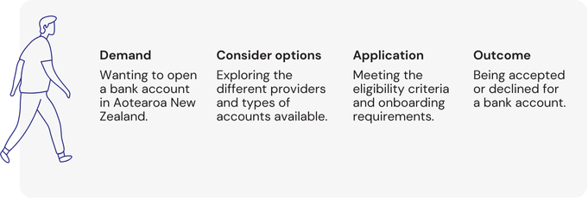
Figure 1. Customer onboarding journey.
Figure 1 chart text alternative: This figure shows the different factors that determine whether a customer can open a bank account, including whether they want to open one in the first place, and whether they are able to meet the requirements for their application for a bank account to be successful.

This research aims to understand the rules and eligibility criteria during the application processes, and how decisions are made that impact customer outcomes. The purpose of this research is to contribute to improvements towards efficient and inclusive customer onboarding processes.
This research provides new insights in the topic of access to banking and builds on existing research
We have undertaken a literature review to determine where to focus our efforts and build on existing evidence. Previous research into access to banking issues explores the barriers experienced by some population segments, such as young people, charitable trusts, Māori customers and prisoners reintegrating into society.
Notable research gaps from existing research include:
- Assessing the scale and drivers of the problem: This research provides a clearer picture of how frequently access to banking issues occur, the underlying drivers, and who impacted customer segments are .
- Exploring decision making practices in banks: This research fills a research gap by looking at the factors that influence the experiences of frontline staff in opening accounts for customers.
- Clarifying risk and compliance obligations: previous research has highlighted ‘grey areas’, or the need for clarity on the relationship between financial inclusion and compliance obligations for opening bank accounts.
This research focuses on addressing the above three research gaps, to help inform RBNZ’s approach to financial inclusion.
It explores the customer onboarding process from two perspectives – staff that work in customer-facing roles in banks, and customers wanting to open accounts. Frontline banking staff (such as tellers and banking consultants) are an understudied population who play an important role in enabling access to bank accounts. We explore how frontline banking staff roles support financial inclusion, the constraints that they face with internal policies and practices, and how decisions are influenced by internal and external pressures.
We also heard from customer segments about the barriers they experience when opening a bank account. We explore the onboarding experiences of whānau Māori, Māori trusts, and small Māori-owned businesses; people living in remote areas, youth, older people and migrants; entities, including trusts and business owners.
The segments we focused on for this research are summarised in Figure 2 below.
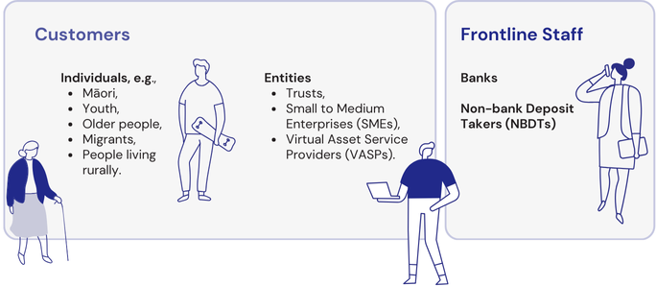
Figure 2. Population groups who took part in this research.
Figure 2 chart text alternative: This figure highlights the different groups who Think Place New Zealand engaged with as part of this research, to understand different barriers that can impact access to bank accounts.
We applied a mixed-method approach to explore three primary research questions
This research draws on qualitative and quantitative evidence. The three primary questions that have guided our research were:
- What are the experiences of frontline banking staff in opening bank accounts?
- What are the experiences of impacted customer segments in opening bank accounts?
- What do best practice approaches look like for promoting financial inclusion?
Further information on our research methodology and research questions from both the survey and qualitative research have been supplied as Appendix 1 and Appendix 2. The remainder of the research commences with our analysis of the results (Section 3). Section 4 summarises the key findings from this report and proposed next steps.

Section 3: Analysis of results
This section presents the findings from our research. The results section has been split into four strands:
- Problems with opening accounts.
- Customer onboarding practices.
- Impacted customer segments.
- Enablers of inclusion.
The results presented in this section are based on a quantitative survey of 722 frontline bank and non-bank deposit taker staff (referred to as ‘frontline staff’), and qualitative interviews with frontline staff and specified customer segments.
It is important to note that many customers who experience issues with access to bank accounts may be temporarily unbanked, and these issues may be resolved in a matter of days or weeks (for example, someone who has left their ID at home when applying for a bank account). For other customers, however, they may find themselves without access to a bank account for months or years (for example, a young person who does not have stable accommodation or proof of their address). Due to the survey techniques, this research is not able to outline the average amount of time taken to resolve access to banking issues, or present a population representative estimate of total number of people who are unbanked at a given time.
The perspectives of frontline staff are useful in understanding the frequency of issues and underlying drivers of access to banking issues. Additional information on the sample techniques and research methodology has been provided in Appendix 1. Efforts have been taken to gather insights from a diverse perspective of frontline employees from a range of regions, roles and financial providers.

Experiences with opening bank accounts
Frontline staff told us how often they face difficulties in opening accounts
The frontline staff survey asked about the frequency of issues they faced when onboarding customers. Figure 3 below suggests that approximately a third of frontline staff reported they were not able to open a bank account for someone often (on a monthly basis) or very often (on a weekly basis).
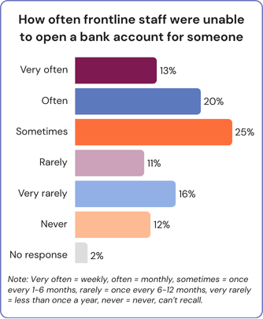
Figure 3. How often frontline staff were unable to open a bank account for someone, shown as percentage of all respondents.
Figure 3 chart text alternative: This chart shows the frequency that staff reported not being able to open a bank account for customers. The distribution of responses is weighted towards frontline staff not being able to open accounts sometimes, with a quarter of participants reporting this at least once every six-months.

Auckland and Wellington had the lowest number of respondents reporting they are unable to open an account often or very often (Auckland: 29% and Wellington: 28%), with respondents from the Bay of Plenty having the highest number of frontline staff reporting they cannot open accounts for customers often or very often (54%). Just over a quarter of frontline staff (28%) indicated that they never, can’t recall or are very rarely not able to open an account for a customer.

Frontline staff provided information on key barriers
Participants identified the main reasons preventing them from opening accounts. Table 1 (next page) highlights that the five most common barriers for opening accounts are:
- Lack of proof of physical address;
- Complexities of paperwork, including verifying customer information, establishing a customer profile, or verification of documents;
- Lack of photo identification;
- Language barriers;
- Lack of access to a bank branch, i.e. over-the counter banking services.

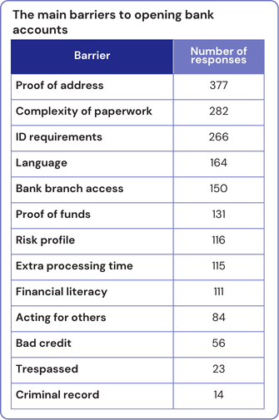
Table 1. Barriers that frontline staff reported experiencing ‘often’ and ‘very often’, shown as the number of responses per barrier.
Table 1 text alternative: This table shows the main barriers that frontline staff reported, with staff most commonly reporting barriers associated with completing proof of address (377 responses), complexity of paperwork (282 responses), ID requirements (266 responses), language barriers (164 responses) and bank branch access (150 responses).

Other identified barriers (not included in Table 1) were organisational internal policies, protocols and processes (i.e. visa and residency requirements), specific customer due diligence requirements (i.e. source of wealth or source of funds), working through mandates and signatories that specify who can control and access an account, getting parent or caregiver consent for minors and youth, internal bank systems and technology, the length of time involved in the process, and the capability of both frontline staff or customers.
Frontline staff described key barriers to bank accounts during interviews and free-text responses
Frontline staff noted that identification and address verification were often considered to be one of the main challenges with providing bank accounts. Some participants raised concerns about how difficult it can be for some customers to meet identity and address verification requirements, which are necessary to open a bank account. For example, two participants explained the challenges they face regarding ID and address checks:
“It's quite a high threshold for proving your identity. And as well, I think having proof of address you have to have something in your name... So, like a lot of minors were having difficulty because they don't have any like liabilities in their name or any, you know, bills… it can get really hard to provide proof of address or if you are unhoused as well or if you are in short term accommodation.”
— Frontline staff
“It can be really difficult if you don’t have the correct ID. If you don’t have the correct type of photo ID that can be considered acceptable you won’t get an account.”
— Frontline staff
Some staff noted that they can also find it difficult to determine what is a legitimate form of proof of identity or proof of address. For example, we heard that some staff would request that customers provide documents certified by a Justice of the Peace, solicitor or police officer to confirm legitimacy. We also see in the above accounts that documents have to include the customer’s name, which can be an issue for some people who may have bills addressed to a family member, or for who have changed their names (e.g. through marriage). Similarly, we heard that verifying someone’s identity can be harder because of narrow criteria regarding the types of information that can be accepted, as explained by two participants:
“For our particular organisation, [the proof of address] has got to be issued in the last 12 months. So they’ve got a tenancy agreement but they might have been in there for two years, so it’s null and void.”
— Frontline staff
“And the only [proof of address] that I can say that is consistently good is a bank statement. And a lot of banks won’t take their own bank statement.”
— Frontline staff
These quotes suggest that the rules and internal policies around acceptable documentation can be a barrier to opening accounts.
We also found that there were inconsistencies in ID and address verification practices, where some frontline staff applied a higher bar or threshold for opening accounts, and there could be additional steps involved in meeting customer due diligence requirements (for example, needing an ID to be verified by a Justice of the Peace).
Customer and frontline staff awareness was also considered to be an important factor
Some frontline staff reported that the understanding of the onboarding rules and requirements among customers was low, which could be a barrier itself. Varying levels of awareness, missing information and incomplete documents were reported as a possible source of friction for both customers and frontline staff. Information and awareness gaps between staff and customers could lead to dissatisfaction or prolonged ‘back and forth’ scenarios.
“[One of the challenges is] customers not reading or understanding what is required from them before the accounts can be opened [and] not completing documentation properly before returning them back to the bank… so that’s probably back to an educational piece. I feel a little bit like there’s lack of information out there from the bank’s website…"
— Frontline staff
“Customers argue the need to provide us with the information and amount of information required. Often there is a lot of going back and forth between staff and customers with requirements from the onboarding team and things can be miscommunicated.”
— Frontline staff
Some frontline staff explained that tensions could occur between staff and customers. In extreme scenarios, frontline staff referred to instances of violent or aggressive behaviour that could lead to some people being unable to access services or trespassed from branches.

Customer onboarding practices
The majority of frontline staff reported they have limited discretion to apply flexibility
We asked frontline staff about the levels of discretion they have in applying policies, protocols and standards during customer onboarding. For the purposes of this research, discretion means:
- how much autonomy a staff member has to vary an existing onboarding process,
- the ability for frontline staff to start an exception-handling process, or
- their ability to help a customer to complete customer due diligence checks.
Discretion was outlined in the Westpac Access to Banking Aotearoa Report as an important question to be explored through further research. For frontline staff, the term ‘discretion’ was understood by some participants as being able to work with a customer and their specific circumstances to enable them to use a variety of information to meet criteria to open a bank account:
“Discretion for me means that I can call customers and I can coach them through how to get stuff done. I can workshop with them before they attempt to onboard.”
— Frontline staff
“I’ve got a little bit of discretion in terms of being able to have the full scope of acceptable documents [and] find ways to make them work.”
— Frontline staff
As shown by the quotes, discretion was seen by some staff as their ability to apply onboarding rules in a way that suits the customer's needs or using a variety of information to meet onboarding criteria.
We asked frontline staff what level of discretion they feel that they have in their role, including their ability to initiate exception handling processes. Figure 4 below outlines the results.

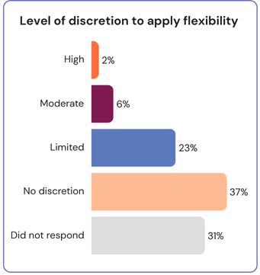
Figure 4. How much discretion frontline staff reported having when onboarding customers, shown as the percentage of all respondents.
Figure 4 chart text alternative: This chart shows the level of discretion that participating frontline staff reported to apply flexible onboarding processes. The distribution shifts towards most frontline staff reporting they have no discretion (37%) or limited discretion (23%) of respondents.

Most participants (60%) reported no or limited discretion during customer onboarding, with 8% of respondents having a high or moderate level of discretion. An in-text response to this question helps to explain how discretion can be understood:
“We don’t make the rules, we just follow what’s set out to be law”.
— Frontline staff
This statement reflects a view shared by some participants who mentioned facing constraints beyond their control that prevent them from opening bank accounts. Using cross analysis, we found that there was no relationship between the level of discretion that frontline staff reported and their job title, the length of time they had spent in their roles, or whether they had received training or not.
We asked about experiences completing staff training and staff awareness of internal policies that allow exceptions to be made
Most survey participants (60%) reported that their employer had policies in place to support flexibility and exceptions for onboarding customers. 40% of frontline staff reported that their employer did not have policies in place to support flexibility and exceptions for customer onboarding, or they were not sure.
We also found that 54% of participating staff reported they had been trained on how to apply flexibility in the onboarding process, while 31% reported that had not been trained and 15% were not sure. Two participants discussed the relevance of training when assessing and considering applications:
“If there's the proper training and sign off internally, I would feel capable to approve some exemptions as well. At least for some, you know, you could differentiate that in different levels, like for individuals or for children.”
— Frontline staff
“We can require CDD [customer due diligence] for up 6 parties at times and we have no training, at times I feel like a lawyer and do not feel comfortable”.
— Frontline staff
These statements reflect a theme from our interviews that limited training or discretion can make it difficult to follow exceptions when challenges emerge. As a result, some staff reported having to take a ‘no exceptions’ approach, or having few opportunities to work with customers to find alternative ways of onboarding them.
We asked frontline staff about the approach they are encouraged to take during customer onboarding
An important aspect of customer onboarding practices and decision making was the internal pressures frontline staff face, and how internal audits affect their work environment. Figure 5 summarises the results regarding the approach frontline staff are encouraged to take during their interactions with customers during onboarding.
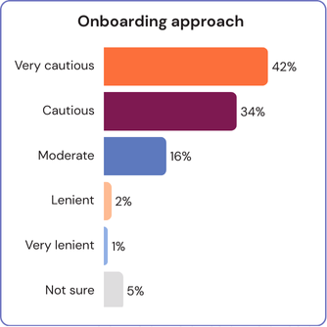
Figure 5. The approach frontline staff reported being encouraged to take when onboarding customers, shown as the percentage of all respondents.
Figure 5 chart text alternative: This chart the distribution of responses regarding the approach frontline staff feel they are encouraged to take during customer onboarding processes. The chart show that most frontline staff reported a very cautious (42%) or cautious approach (34%) to customer onboarding.

Most frontline staff reported taking a cautious or very cautious approach to customer onboarding (76%) with around 16% reporting that they take a moderate approach. Our cross analysis found regional variability in responses, as seen in Figure 6 (right).
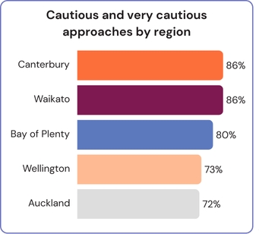
Figure 6. Percentage of staff within each region that reported being encouraged to take a ‘cautious’ or ‘very cautious’ approach, shown as the percentage of respondents for each region.
Figure 6 chart text alternative: This chart shows that some regions had a slightly higher proportion of respondents that reported they are encouraged to take a cautious or very cautious approach to customer onboarding. At the top end, Canterbury is shown as having 86% of respondents reporting a cautious or very cautious approach to onboarding compared to 72% in Auckland.

As above, a greater proportion of frontline staff from Bay of Plenty, Canterbury and the Waikato reported taking a cautious or very cautious approach than those in Wellington and Auckland. Frontline banking staff from Auckland were also more likely to report:
- Being trained to apply flexibility: 20% of staff in Auckland reported that they had not being trained to apply flexibility, compared to 33% in the Waikato and 43% in the Bay of Plenty (see Figure 7 on next page).
- Less frequent issues with not able to open bank accounts for customers: 30% of staff in Auckland reported they are not able to open a bank account 'very often' or 'often', compared to 39% in the Waikato and 34% in the Bay of Plenty (see Figure 8 on next page).
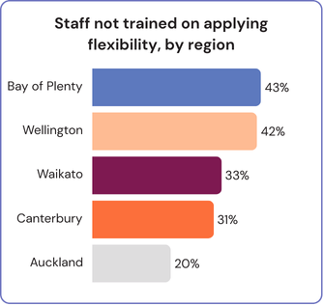
Figure 7. How many staff within each region reported that they have not been trained to apply flexibility, shown as the percentage of respondents for each region.
Figure 7 chart text alternative: This chart shows that some regions had a slightly higher proportion of staff that were not trained on how to apply flexibility in customer onboarding. At the upper end, 43% of participating staff from the Bay of Plenty reported not being trained compared to 20% of participating staff from Auckland.

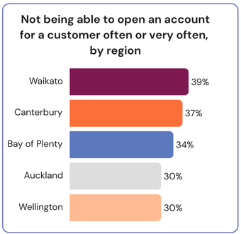
Figure 8. How many staff within each region reported being unable to open bank accounts ‘often’ or ‘very often’, shown as the percentage of respondents for each region.
Figure 8 chart text alternative: This chart shows that some regions had a slightly higher proportion of staff that reported not being able to open a bank account for a customer, often or very often. Waikato had the highest proportion of staff not able to open accounts for consumers on a frequent basis at 39%, whereas Wellington and Auckland had the lowest proportion at 30%.
We have not undertaken statistical analysis to imply causation. Further work could explore regional differences in customer onboarding practices, whether proximity to a bank’s head office has an impact on onboarding practices or staff training, and other possible causes of regional variability (such as demographic factors).
We heard that the importance of accuracy and a fear of making mistakes can be a barrier during customer onboarding
In qualitative interviews, we learned that quality assurance processes are commonly used to ensure accuracy and adherence to customer due diligence practices. One staff member shared that the quality assurance process involves checking the correct documentation has been obtained from customers, with efforts to address any gaps that emerge. The participant described the back-and-forth nature of remediations:
“The compliance team will do audits…the front [of the drivers license] is actually too blurry …can you please go back to the client? You've opened this trust profile [and] we're missing a foreign text self-declaration form… please refer back to the client...”
— Frontline staff
The work to remedy missing information and refer back to customers can fall on the frontline staff member rather than compliance teams. We also heard during interviews that remediation processes can be a cause of stress and anxiety.
“Policies to be adhered to and QA reviews that could result in job loss if we get something wrong.”
— Frontline staff
“If incorrect, we receive straight fails for QA reviews on our employee record...[they] can make some staff members feel anxious and start to doubt their abilities in their role…”
— Frontline staff
“If you get told that’s failed, you kind of just feel like, oh my God, I’m a failure.”
— Frontline staff
As with the above accounts, we found that some staff reported consequences if they fail quality assurance reviews, having implications for performance reviews and the confidence they have in their roles.
It was common for frontline staff to report a fear of making mistakes can influence decision making. This contributed to some staff preferring to decline a customer’s application rather than dealing with the repercussions of a failed audit.
“We are reprimanded if we fail CDD onboarding. So, we are all terrified of getting it wrong. And because we don’t have any discretion to make decisions, we will just turn customers away if they don’t meet our requirements.”
— Frontline staff
This excerpt demonstrates how a low tolerance for failure can underpin a risk averse approach to customer onboarding. Similarly, another participant noted that there can also be internal pressures associated with both quality assurance and the time spent with each customer:
“We definitely get QA a lot and there can be a little bit of pressure to make fast decisions…so [if] it seems like this [customer’s application] is going to be too much work for me to explain to the customer how to do this in a way that would work or I can’t be bothered escalating…I’m just going to decline it and tell them to reapply.”
— Frontline staff
Overall, we heard from research participants that being encouraged to take a very cautious approach, facing internal time pressures, and few pathways for using exceptions or flexibility to onboard customers can contribute to instances where customers are turned away.

Impacted customer segments
This section focuses on the experiences of particular customer segments with opening bank accounts. Based on the range of impacted customer segments, it was not feasible to analyse access to banking barriers for all customer segments. We also note there can be a layering of challenges and intersectionality, for example, some customers may live in rural areas and be represented across multiple groupings. This section takes a particular focus on elements such as visa status, age, individuals vs. entities and immigration status, and whether these factors have an impact on the onboarding process.
We heard that specific groups in society can face barriers to open bank accounts
This research explored whether some groups in society experience disproportionate barriers when attempting to open bank accounts. According to bank staff, recent migrants and non-English speakers were reported to be most likely to experience difficulty opening an account, followed closely by people living in rural or remote areas, trusts and not-for-profits, and older people (see Figure 9 below).

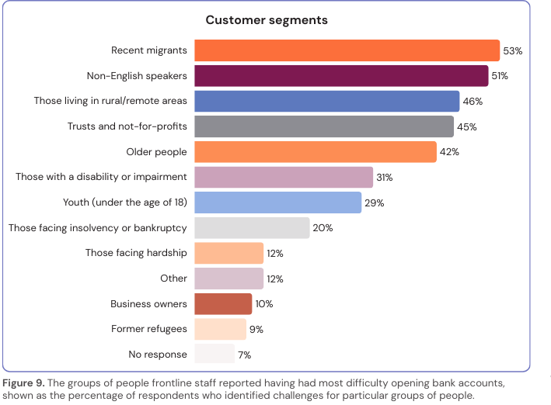
Figure 9. The groups of people frontline staff reported having had most difficulty opening bank accounts, shown as the percentage of respondents who identified challenges for particular groups of people.
Figure 9 chart text alternative: This chart shows the distribution of responses regarding customers that were identified by frontline staff as having the most difficulty opening bank accounts. The responses were highest for recent migrants (53%), non-English speakers (51%), those living in rural/remote areas (46%), and trusts and not-for-profits (45%).
Free-text responses indicated groups that can be most likely to have difficulty opening bank accounts can also include:
- youth no longer living with their parents, or are not in the care of those named on their birth certificate,
- Māori landowners,
- overseas customers,
- homeless people,
- people who have had a bank account shut down for reasons that they don't want to disclose,
- former prisoners,
- people who don't work and most bills are paid under a partner or other family members name, and
- victims of domestic violence and abuse.
One participant noted that it is not easy to determine specific groups or customer segments who are most likely to have difficulty:
“Not a specific group of people I would say, I have come across all walks of life that have had issues with barriers.”
— Frontline staff
While it was more common for staff to highlight specific customer segments where access to banking challenges can be felt most acutely, this perspective suggests that it may be hard for staff to rule out a customer group that has not (or may not) be impacted by barriers to open a bank account.

Immigration status
Frontline banking staff reported that people who recently moved to New Zealand often struggle to meet customer onboarding requirements. One staff member mentioned that these customers must follow different steps, such as visiting a physical bank branch in person, as per the entity's standard procedures:
“We can still join foreigners. It just needs to be done physically in branch with, with their foreign passport. So it can be, yeah, I mean, there's just a little more scrutiny, with, with resident visas and things like that.”
— Frontline staff
One frontline staff member elaborated that a customer’s country of origin was also a relevant factor for them when undertaking customer due diligence checks for recent migrants. In such cases, additional scrutiny can be applied.

“So for any country that you know [is] on our list for being classified as high risk or extreme risk jurisdictions for developing countries because the country has, you know, not so good or loose systems around monitoring transactions. So therefore, when we try to onboard customers from those countries that can be very difficult for them to provide things we call source of funds documents. If we imagine lots of things are in cash transactions how can they, you know, provide those documents?”
— Frontline staff
This statement suggests that additional steps may be required to open bank accounts depending on someone’s country of origin, or how an entity assesses the risk of criminal activity or regulatory practices in other countries.
We also heard that proof of address requirements can be particularly difficult for some recent migrants to meet as they are still establishing themselves and may not have a permanent address:
“There is a whole bunch of stuff I did not have - I needed proof of address, which of course is complicated because in order to get proof of address, I need to pay like the deposit and also rent, which I couldn't do because I couldn't access my money. So, it was very much like you need a bank account to get proof of address and you need proof of address to get a bank account.”
— Customer
The interdependent requirements were described by another participant:
“It becomes a bit of a chicken and egg scenario. It's like, well, I can't put my deposit down on my flat till I get paid, but I can't get paid until I've got my flat and got my proof of address so you end up in a circle.”
— Customer
These statements reflect the challenging relationship between requirements, where some customers reported finding it difficult to establish themselves in New Zealand without a bank account, which is tied to their ability to access employment, find fixed accommodation and make daily payments. The circular criteria of opening a bank account for recent migrants has been visualised in Figure 10 below.
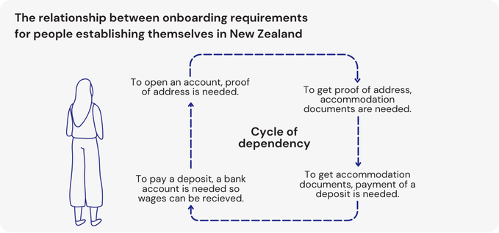
Figure 10. The relationship between onboarding requirements for people establishing themselves in New Zealand.
Figure 10 text alternative: This diagram visualises how people can face a vicious cycle, where they are not able to get a bank account because they do not have a fixed address and they are not able to secure accommodation without a New Zealand bank account.
It was reported that bank staff may require some customers to justify why they need an account
We also heard informal requirements for recent migrants, where one participant highlighted that they had to convince a staff member that they needed a bank account to support their ability to live and work in New Zealand:
“I'm here on working holiday and immediately the teller was like, you can't make a bank account if you're on working holiday... And I was trying to explain I have to pay rent… and she was like well if you’re just on a working holiday visa you shouldn’t need a bank account… so it kind of felt like for the first maybe 10-15 minutes I was just like trying to convince her that I actually did need a bank account… I did directly ask, like is [your bank] not a foreigner friendly bank and she was like no it’s not sorry...”
— Customer.
In addition to the factors related to visa status of customers and their intentions to work in the country as above, we also heard that the length of time a customer was going to be in New Zealand was often considered when assessing the customers application:
“If someone’s going to be here for a long time then it probably becomes a necessity… we don’t want them to carry a lot of cash and not all shops or places accept overseas visa cards.”
— Frontline staff.
These accounts reflect that some frontline staff may ask customers about their circumstances and why they need a bank account. This may relate to entities meeting the AML/CFT requirements to obtain information on the nature and purpose of customers opening a bank account. These requirements are primarily designed to ensure customers have legitimate motivations for opening accounts to prevent them being used for criminal activities. However, we see from the previous statement that temporary visa status can be interpreted by some frontline staff as customers not having a need to open an account.
There was an underlying theme that customers from overseas have a higher threshold to meet in terms of proving they need a bank account for their application to be successful.
We heard that blanket exclusion policies can impact people on short-term visas
One frontline staff member that we interviewed noted that customer onboarding processes are influenced by blanket rules that relate to an entity’s level of appetite to establish business relationships with some customer segments. The concept of a blanket exclusion to customer onboarding for people on short-term visas is explained below:
“As a blanket rule we don’t open accounts for visitor visas… so as a majority of the time we do turn those people away on student visas… While I have worked in banking it’s always been a blanket rule - we don’t open those accounts for those people.”
— Frontline staff.
In the statement above, we see that different types of temporary visas that can be treated similarly are captured by blanket exclusions. The limited appetite among banks to onboard people on temporary visas was also reflected by the experience of a recent migrant when attempting to find a bank in New Zealand that would be likely to accept their application:
“I asked around my other working holiday friends and groups online… [I found] a list… and here are the banks that you should go to and here of the banks you don’t, like pretty much all of the banks were on the list of ‘don’t go to this [bank]’.”
— Customer.
The experiences of frontline banking staff and customer segments who participated in this research suggests that some customers may be unable to open a bank account, or face heightened scrutiny, based on where they are from, how long they intend to live in the country, or their ability to convince frontline staff of the need to open a bank account to manage their money and establish themselves in New Zealand.

Impacts of age
Young people may face specific barriers to open bank accounts
We also heard that age may affect the customer onboarding experience. In some cases, we heard that opening a bank account can be more difficult for children and young people due to the need for parental involvement and obtaining account mandates or signing authorities:
“For younger tamariki in particular… [or] if they are in the care of Oranga Tamariki it's almost impossible to get them a bank account because it has to be associated with a caregiver or guardian set up. So for those younger tamariki… there just does not seem to be a way to get them into that sort of early banking habit. Which we would argue then impacts their ongoing financial literacy as they mature and grow up.”
— Customer.
This statement highlights that customer onboarding can be more of a challenge for young people, particularly those in state care due to the important role of a parent or guardian.
This also makes a connection between financial inclusion and financial literacy, where being able to open a bank account then enables young people to have positive learning experiences with managing their money.
This participant noted that in their view, there is not a safe, consistent or standardised way to open a bank account for young people, which can also be driven by the costs, time, and accessibility to their documents:
“I have heard of people having to wait for a visitation with a parent to try and access their original birth certificate because they have not got it themselves… And then, I mean, sometimes they will apply for a passport but, you know, there's a big cost associated with that and [especially] if you are not traveling.”
— Customer.
This participant also noted how it can be difficult for young people to provide proof of address and to go into a bank branch to do the initial set up, especially for those whose living situations are fluid. One participant elaborated that for young people, a bank account can be vital for their ability to move into work or receive financial support:
“We've heard stories of young people coming out of care.. but then they couldn't actually get paid the benefit because there was nowhere to pay it to [because they] don't have that account. Or they have started a new job and they couldn't get paid for weeks and weeks because they couldn't get the documentation that they needed to open the bank account to pay it into. So it is having some quite significant impacts - they can't receive an income.”
— Customer.
This account outlines how for young people, a bank account can be fundamental for their transition to adulthood.
In addition, two staff noted that the criteria to open accounts have been moving:
“... So I can speak for my own and then from what we’re seeing today. So when I first got my first job at 11… I was lucky to live in a small town where there was only one bank… But I know that what a lot of young people today nowadays are struggling with is they don’t always have access to their own ID. ”
— Frontline staff.
“It's gone too far. The days that you could just walk into a bank and present your single only photo ID and, oh, that's me, and you get an account open within minutes. So that doesn't exist anymore.”
— Frontline staff.
These statements suggest that customer onboarding requirements are becoming more difficult or unclear, having a greater impact on young people opening accounts today. Overall, participants in this research said that access to banking challenges can be significant for young people, as they are often in a position where they may have less autonomy or resources themselves, and more reliant on other people in their lives to support customer onboarding or advocate on their behalf.
Older people were also reported to face challenges opening bank accounts
Some participants reported that older New Zealanders are a customer segment that can face unique or disproportionate barriers when opening bank accounts. For example, one staff member noted that they see issues where older customers may not have the documents needed to meet customer onboarding requirements:
“I was at a bank with my mom who's 85 and she doesn't have any current photo ID… So, they took her gold card and an expired driver's license. Now another bank I went to with her would not accept that.”
— Frontline staff.
This account highlights how older people may not renew documents, such as a driver’s licence, which can then complicate their experiences with customer onboarding.
This statement also illustrates how some older people may be reliant on a friend or relative to support them going to a physical bank branch and advocating on their behalf.
Another participant shared a similar perspective that maintaining up to date identification can be a particular barrier for older customers:
“So with the anti-money laundering law, they have to provide updated ID current with a photo. That can be an issue for a lot of elderly people that don't have a licence anymore and are never intending to travel, so they don't have a passport… I see elderly people are quite vulnerable because they haven't documented stuff... And I see that same frustration and elderly people with technology changing and trying to get bank accounts open. It's not easy.”
— Frontline staff.
We also heard that some older customers can find digital onboarding processes challenging, and customers’ applications may be declined if photos or information is not completed appropriately, as discussed by one staff member:
“They need a chip passport to be able to verify themselves online… The process of joining on the app, it takes about 10-15 minutes sort of depending on how savvy you are with tech… Generally you’ll see more sort of elderly people struggle with using the app. Or when the phrase comes to record or something like that they don’t quite see it on the screen, or they read something else, or they get their husband or wife to look into the camera as well so we’ve got two faces and we can’t use the video.”
— Frontline staff.
As above, it was common for participants in this research to report that some older customers cannot meet the criteria of opening a bank account due to the expiry of documents, digital literacy, and/or can be more reliant on having support from a family member.

Entities (businesses and charitable trusts)
This research explored the differences between customer onboarding for individuals and for entities, including not-for-profits and businesses.
Our survey results found that 83% of participating bank staff said that it was harder to open an account for an entity than an individual.
13% of respondents reporting that there is no difference in difficulty, and 4% reporting that it is harder to open accounts for individuals. We explored customer onboarding experiences for both not-for-profits and business owners through a survey of frontline staff, and a small number of qualitative interviews with entities themselves.
Staff reported that they found onboarding not-for-profits to be complex
Not-for-profit entities such as bridge clubs, churches, and community organisations experience enhanced customer due diligence processes, which involves additional steps such as proving where the trust’s money has come from. As per Figure 9, 45% of frontline staff identified not-for profits as a group that are most likely to face difficulties opening bank accounts. As explained by one participant, the ownership structure of trusts and additional requirements can make customer onboarding challenging:
“Trusts can be a nightmare for some people. They’ve got to supply all of their ID and everything… some banks require the information around the beneficiaries. It’s just a yucky process. You ask any bank staff if someone comes into a bank across all banks and says they want to open a trust account or a not-for-profit organisation and our heads, we’re all rolling our eyes like it’s just not nice.”
— Frontline staff.
This account notes that some frontline staff find onboarding trusts difficult. Two other participants highlighted complexities:
“More documentation is required for entity onboarding and sometimes more people are involved that are hard to contact or are living overseas. Some customers are reluctant to share information or can't be bothered and get annoyed with the bank policies.”
— Frontline staff.
“It is again dependent on how the trust has been set up. If there are multiple companies as trustees and companies as directors of those companies, it becomes a Russian doll, where to open one trust profile and account we end up opening 10 + profiles. Some trusts can be extremely straight forward with only two or one person as trustee.”
— Frontline staff.
We also found varying practices in the way frontline staff determined whether trustees needed to come into a physical bank branch to be onboarded, and whether all trustees needed to complete customer due diligence requirements. One participant explained logistical challenges of verifying the identities of multiple trustees:
“We understand that it's not an easy task [opening a bank account for an entity], especially considering something like a choir or nonprofit organisation. You bring everyone at the same time at the same day to the same spot. Sometimes they are not even in the same city right? But we do have flexibility. So one of the members can go to another branch in town and we can manage that.”
— Frontline staff.
This account highlights that some frontline staff are able to apply flexibility to try and improve the process of onboarding multiple trustees, however, onboarding trusts is not considered to be an easy task for many of the staff that participated in this research.
We also heard from a small number of business owners regarding customer onboarding practices
Business owners were another focus group that we met with to discuss access to banking as part of qualitative interviews.
Our survey found that 10% of frontline staff see business owners as group that is likely to experience difficulty opening a bank account.
One business owner in the study reported that their application process was challenging due to limited access to tailored business banking services:
“Locally, I guess being in, what do you call a semi-rural kind of area, you know… We do not have any business bankers locally. That is what I found out. I thought we were dealing with the business banker, but we apparently had none locally.”
— Customer.
This statement suggests that people can have varying experiences when engaging with frontline staff, and this participant found their particular region has limited access to specialist business support.
We also heard from one participant that there can be a connection between access to bank accounts for businesses and risk appetite, relating to the sector they operate in:
“I think it is the compounding factors of it is new and confusing [industry] and people do not understand how it works… I wrote a really comprehensive AML compliance program and risk assessment… and I went around to talk to all of the banks and got no from all of them… And so with all the banks that I was going to, the easiest answer was no… I wasn't even getting an appointment...”
— Customer.
This statement suggests that banks can have a low appetite to consider providing a bank account to businesses in particular sectors, in this case, a virtual asset service provider. This participant reported to us that their risk management practices did not necessarily improve their chances of opening a bank account, suggesting that some entities may have blanket exclusion policies for onboarding businesses in sectors deemed to be high risk.
This business owner later commented that their ability to be involved in commercial activity was eventually based on the motivation and support from one particular staff member:
“We have employed hundreds of people over the years. We have served hundreds of thousands of Kiwis. And all of that was possible only because one person and one bank decided to actually give us a chance… The existence of my entire business comes down to one person having, you know, taken a punt on us.”
— Customer.
This statement reflects findings from the Better Banking Report, that some frontline staff go above and beyond to onboard some customers.
These customers are referred to as ‘golden unicorns’ in the Better Banking Report. This case suggests that some frontline staff play an important role in supporting financial inclusion due to their capability to meet internal requirements and being highly motivated to support positive customer outcomes.
We also heard from another business owner that the onboarding process was relatively easy for them:
“Opening the bank account was reasonably straightforward and easy. I think I filled out a form online [and] had to go to the branch and sign a mandate or something along those lines. So that was pretty easy.”
— Customer.
This statement was from a small business owner whose experience opening a bank account had very little friction. Given the small sample size for our qualitative research with business owners, it is difficult to make inferences about general trends or barriers faced by this customer segment. However, further research could be valuable to unpack how the perceived risk associated with some sectors can impact their ability to open a bank account and engage in commercial activity.

Māori perspectives
This section explores Māori perspectives and experiences with opening bank accounts.
This research is based on semi-structured interviews and small group discussions with 14 participants, including whānau Māori, Māori SME owners, and those involved in collective governance as part of charitable trust structures and post settlement governance entities.
We note that these findings are not representative of broader Māori perspectives, and acknowledge that the views and experiences of iwi, hapū, and whānau vary.

Historical and social context impacting demand
Within the kaupapa Māori element of this research, interview participants often contextualised their experiences of opening a bank account within the broader historical, social, cultural and aspirational context:
"Whānui ake ngā whakaaro atu I te moni.” (Our thoughts are much broader than just money)
- Customer.
Some participants noted that their thoughts and decisions around money and banking are driven by a wide range of factors, such as trust in providers, collective wellbeing, and relationships with people. Some Māori participants told us that the idea of being dependent on a non-Māori owned and operated financial system sits uncomfortably for them. Before talking about access to bank accounts, some participants discussed the impacts of history and financial colonisation relating to land alienation, sharing their perspective that financial providers do not operate to meet the needs of Māori.
Some participants reported that they preferred to operate outside of the banking system and primarily use cash, and felt unease when they were required to open a bank account for themselves or to support their whānau.
Some participants also had deeply held values and perspectives that they do not see the banking system working for them:
“It’s a cycle of inequities and [the system] is not equipping our people.”
— Customer.
This quote reflects a tension, where it was reported by some participants to be hard to fully understand Māori perspectives on customer onboarding experiences without first considering the broader factors that can impact levels of trust and engagement with the banking sector. In undertaking this research, we note a research gap in understanding Māori perspectives in terms of the use of money, trust in financial providers, and how financial products and services can better support and sustain Māori economic aspirations. Further work may be required to adequately unpack how Māori perspectives, aspirations and experiences influence demand for bank accounts in the first place.

Bank accounts and collective wellbeing
Bank accounts were often reported to be a necessary tool to support collective wellbeing
We heard that collective thinking and collective wellbeing can be at the heart of Māori social structures. Some participants reported that their decision to open a bank account related to their aspirations for their community or whānau. For example, one participant talked about the importance of bank accounts in driving community initiatives:
“[bank accounts help] whānau Māori to have funding available to them and their communities…it needs to be more accessible.”
— Customer.
Two participants discussed the time and effort that were required to open an account when working as part of a collective, and highlighted that obtaining proof, the amount of documentation, and the costs involved in the process could be challenging:
“It takes months…emailing and talking to them [the bank] several times a month, sometimes visiting a bank branch for over an hour”
— Customer.
“We had to pay a lawyer or accountant to write a professional letter [to the bank] and they need to get paid to do this work.”
— Customer.
Māori research participants reported that many forms of ID that are required are not held by some people, and proof of address is not always easy to supply. Two participants pointed out that registering a Charitable Trust is part of a broader process (for example, involving registration with the Māori Land Court), and banks also require evidence of funding sources, proof of address, and verification of multiple trustees.
Layering of requirements when opening a bank account can make it difficult to establish and operate a Māori charitable trust.
One participant told us that due to the time taken to open the account, the planned funding source had been lost as that round of funding had ended, and the application had to be restarted. During our research it was common for participants to consider that the rules and processes during customer onboarding were not fit for purpose for Māori charitable trusts.

Barriers and opportunities for Māori participants
Some participants emphasised the importance of cultural capability and support to navigate the banking system
Some interviewed participants reported that having access to support and information on onboarding processes can be hard to find and make sense of. We heard that information from on-line resources is difficult to navigate and is often incomplete, increasing the need to speak to the someone in the bank:
“It’s hard to find out who to speak to, finding someone who knows the process, who understands the context. [Bank] tellers don’t communicate with the team who set up the account, there’s no knowledge.”
— Customer.
Many of the participants told us about the value and necessity of having a navigator or someone who can help them through the customer onboarding process.
The most important sources of support and guidance that people told us about were Māori individuals who either worked in banking or had previous experience of navigating the process (including a Māori business association). On one hand, two participants noted that the cultural competency of bank staff and being able to speak with Māori bank staff were important factors in creating a positive onboarding experience:
"We had someone walking us through the process making the calls, setting up the hui. We just needed to take our ID. If this is possible for families, that's good".
— Customer.
“We do well when there’s a sense of familiarity – who we are engaging with is more important than what we are engaging about.”
— Customer.
However, other participants noted that in their experiences with banks the level of understanding of Te Ao Māori and cultural capability was low:
“[The bank’s] cultural competency was very little. Their understanding of our world was lacking.”
— Customer.
"Even with inside knowledge, we couldn’t open an account".
— Customer.
The accounts above suggest that there are mixed experiences with frontline staff, and that there can be gaps in cultural understanding and awareness that can impact Māori experiences and outcomes when attempting to open bank accounts.
We also heard a desire for banks and bank products and services to better reflect Māori values and social structures to help meet their needs
Some participants expressed that providers could help to bridge gaps in understanding through proactive outreach to Māori communities. For example, two participants suggested that providers could do more to engage in safe and trusted spaces for Māori communities and be more responsive to the needs of whānau Māori:
“Workshops at the Marae would be great.”
— Customer.
"Banks [should] get out and understand our world. Understand the relevance of who we are how we roll, and better respond to the needs of our whānau.”
— Customer.
Despite the modest sample size associated with this work, qualitative interviews undertaken as part of the Kaupapa Māori strand of this research provide a valuable reference point to reflect on unique barriers and opportunities to support Māori financial inclusion and empowerment in the customer onboarding process.

Enablers of inclusion
This section summarises findings from the research regarding existing practices that can support inclusive customer onboarding experiences.
We heard that banking staff already support financial inclusion
We found that some frontline staff did not want to turn customers away and supported financial inclusion. Some staff members held a perspective that people should be able to access banking services and outlined a perspective that everyone deserves a bank account. This perspective that some staff actively pursue financial inclusion and promote accessible processes was also reflected by one participant who was trying to open a bank account:
“Certainly the ones we have been working with in terms of trying to make things better. When you talk to them they are really open to our perspective on it and those tend to be more sort of national office type people. Those kind of care teams.”
— Customer.
This statement suggests that extra care teams can be helpful in hearing the customer scenario, and finding ways to help.
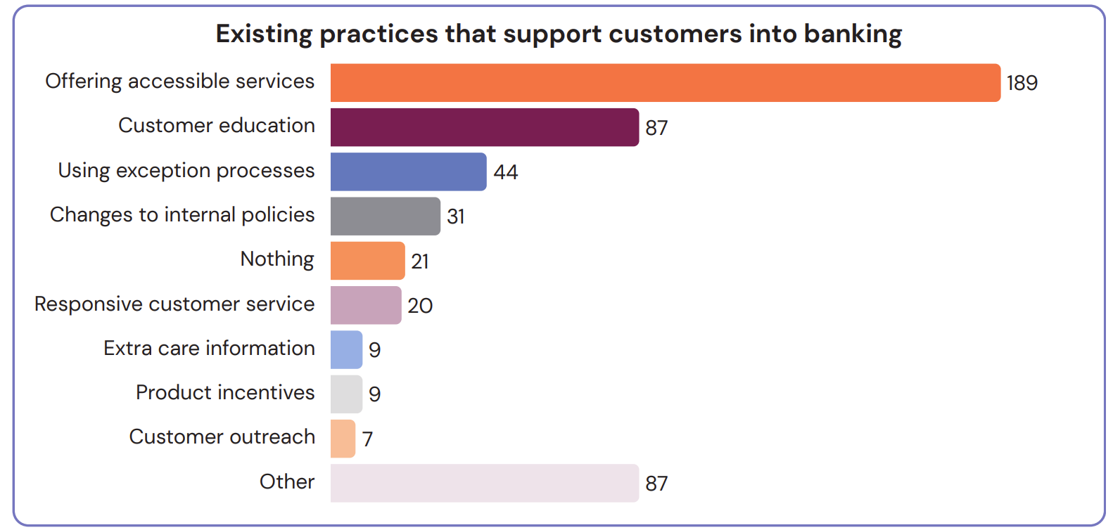
Figure 11. In text responses provided by frontline staff relating to what their organisation does to support customers into banking, shown as the number of respondents who identified each type of initiative.
Figure 11 chart text alternative: This chart shows that the majority of respondents (189) reported efforts they are taking to offer customers accessible services to help customers into banking. Other initiatives reported were customer education initiatives, using exception processes and changing internal policies.

The existing practices reported by staff that support access to bank accounts are summarised in Figure 11. Frontline staff noted that their entities primarily had additional support services that helped customers with onboarding, such as providing various onboarding options (digital and in-person) and providing customer assistance if people face challenges with the onboarding process. The second most commonly reported practices included customer education and internal exemptions.
Other initiatives or factors that frontline staff reported that support access to banking services include fees free accounts, helping people to download and use digital applications, and clear communications on the requirements and timeframe involved in opening a bank account.
We asked for examples where staff applied flexibility to understand how this works in practice
A small number of in-text responses provided examples (n=36) of a time when a staff member helped someone open an account by applying flexibility. We heard that the most common examples when staff have used flexible onboarding processes include: utilising address verification exceptions (9), internal escalation (7), and supported access to ID (4).
We also heard that some frontline staff refer customers to alternative services or onboarding pathways.
In terms of the options for inclusive onboarding, one participant explained how they are able to problem solve issues with ID to be able to support customers to open a bank account:
“I personally get as creative as I possibly can because I could see I'm a bit of a problem solver… it's just working through it, step by step. So for me it’s like we can accept a vehicle registration by NZTA. So, a lot of people have got a vehicle.”
— Frontline staff.
This account highlights how customers may not be able to provide some information, but there are alternative documents that can be used to meet customer onboarding requirements, and frontline staff can help by working through these options.
We also heard from some customers who had positive experiences with staff who are trying to make things better, and making internal changes to support accessibility:
“Eventually one guy in [bank] who was personally interested, he kind of took it on his personal mission to see if this company can get a bank account and if it can't, I want to find out why. And so we owe our business to that guy and he took it through all of the compliance and risk hurdles.”
— Customer.
This quote highlights how some frontline staff are able to work through challenges, and do what they can to find a viable solution to onboard the customer. We heard a range of ways frontline staff supported financial inclusion that are in their control or influence.
We asked staff about factors that enable them to apply flexibility
We heard from some staff that their ability to follow exception handling processes or spend longer to interview customers was often dependant on the environment or level of support they had. Figure 12 below outlines some of the factors that were considered to enable frontline staff to work with customers and find flexible solutions that enabled customer onboarding.
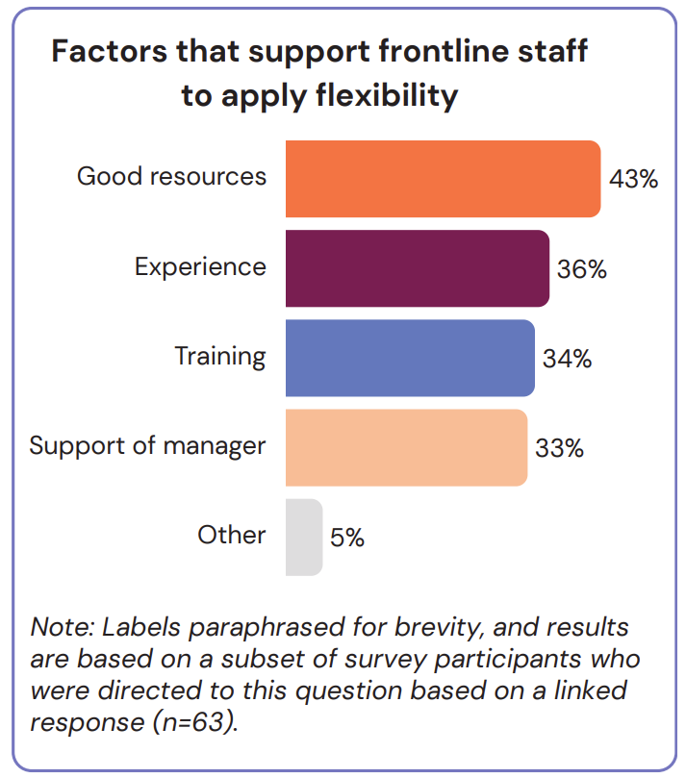
Figure 12. Factors that frontline staff reported that supported them to apply flexible onboarding processes, shown as the number of respondents who identified each type of supporting factor.
Figure 12 chart text alternative: This chart shows that the main factors that were reported by frontline staff to support them to apply a flexible approach to onboard customers were having good resources, experience, training and the support of a manager.

As demonstrated above, having good internal resources, experience in working through scenarios, and internal training and management practices were considered to be the most important factors influencing flexibility and exception handling.
Enablers of inclusion identified in the responses included being able to make some decisions as frontline staff, having good communications skills to understand an applicant’s situation, and having risk level approvals in their role.
We heard some examples of policy changes that support financial inclusion
Some frontline staff highlighted changes to their internal policies that have enabled them to onboard customers. One approach that was discussed by two participants was taking a principles-based approach to meet proof of address and identification requirements:
“What we used to do was have a very narrow range of options where we could accept a certified ID. So we’ve opened it up”.
— Frontline staff.
As above, a prescriptive approach to acceptable documentation was seen as a barrier by some participants to customer onboarding, whereas a principles-based approach enabled some staff to be able to accept what they referred to as non-standard forms of identity, such as doctor’s notes.
Frontline staff noted that exception handling processes and internal escalations are valuable tools for opening accounts
Some participants noted that being able to initiate exception handling processes was supported by central support teams. Some participants reported they can refer cases to support teams for reassurance or guidance on cases, or are able to escalate complex customer scenarios for approvals and/or exception handling processes. As well as highlighting the importance of internal escalation teams in supporting customer onboarding, some participants considered that a delegation of authority based on formalised bank policies could help:
“Address verification can be very tricky. We feel our managers should be trained to approve to speed up the process and approve non-complex address verification when… [there] is a commonsense reason, instead of sending and having to wait for approval answer elsewhere.”
— Frontline staff.
In line with these statements, formalising and streamlining exceptions handling processes was considered to be done differently across entities which impacted customer outcomes and timeframes:
“So I’ve worked previously to [bank] and then before coming to [bank, bank]. So from my experience, I had this couple of cases I just mentioned here at [NBDT]. So that took less than 24 hours to get resolved. If I had similar cases then I had in the past for the other two bigger banks that could take a week or so.”
— Frontline staff.
This statement reflects that the time taken to manage customer onboarding processes can be important for both frontline staff and providers, and suggests that some providers may have expedited the approvals process so that customers receive outcomes on their applications in a matter of days rather than weeks.
System upgrades and third-party providers can be enablers of inclusion
We also heard from some participants that the technology that banking systems rely on can be an important factor in customer onboarding.
For example, one participant noted that the functionality of the banks’ back-end system can make it easier/harder to onboard customers:
“One bank that has got a very good [system]… so say you had a single account and you want to put another person on it and make them a joint owner. So some systems that’s just a really easy click, click sign the documentation to match it, that’s done. Others, actually we can’t do that. We actually have to close the account and open a new one and do a name. So again, that inconsistency across organisations systems behind the scenes.”
— Frontline staff.
The quote above demonstrates how some participants who had worked across multiple entities were able to provide reflections on how internal systems could make customer onboarding easier or harder for certain scenarios. We also heard that some frontline staff were able to benefit from third party organisations verifying some of the documents of customers:
“When they apply, automatically [a third party provider] verifies their address. So yeah, probably about 70% of people are just automatically address verified.”
— Frontline staff.
This example demonstrates how some entities have shifted the responsibility from customers proving who they are, to bank systems verifying the identity of customers. In this way, we heard that digital solutions, online onboarding pathways and third-party verification can be an important enabler of inclusive and efficient onboarding.
We heard from some participants that changes are required to improve customer onboarding
As part of free text responses we asked participants about what they would like to change to improve the process of opening a bank account for individuals or entities. These responses were grouped into key themes.
The most commonly suggested improvements were:
- relaxing ID requirements,
- simplifying onboarding requirements,
- improving digital infrastructure and online onboarding channels,
- customer education,
- removing proof of address, and
- improving internal processes.
Other suggestions included improving access to acceptable forms of ID (such as RealMe), industry standards for onboarding, a central register for customer due diligence checks, improving branch hours or representation. Some staff also suggested refresher courses for staff, clarifying AML/CFT requirements or guidance on required documents, improving banking systems, increasing staffing, and having customer segmentation so that some bankers are trained to support customers in particular scenarios (such as not-for-profit entities).
It was common for participants to see simplification of the onboarding rules being part of the solution to improve access to bank accounts
Simplification of onboarding requirements was a common solution identified to help to improve outcomes and expedite onboarding processes. This position was also reflected in qualitative interviews in line with the statement below:
“Why can’t it be made simpler for customers? One less thing for customers to have to jump through.”
— Frontline staff.
This account indicates that an overall lowering of the requirements would make it easier for customers. There were also responses that a change in discretion, delegations and empowerment of frontline staff to be able to make decisions regarding onboarding would be useful, at least for some customers who may be considered having a lower level of risk:
“If there’s proper training and sign-off internally, I would feel capable to approve some exemptions as well. At least for some, you know, you could differentiate that in different levels, like for individuals or for children.”
— Frontline staff.
These statements provide reflections regarding changes to the way customer due diligence rules are set, interpreted and implemented could improve customer onboarding. We also heard from some participants, particularly among impacted customer segments that efforts should be taken to formalise customers’ rights to a bank account:
“Can you imagine living without a bank account? How would you get paid? How would you do your shopping?.. Like it's actually not possible to function in today's society without banking and as a business, it is impossible. So it must be a right.”
— Customer.
“[Banks] can't just choose the most profitable customers and service them. They have to service everybody…. And because we have a pretty much cashless society, people are actually excluded from the finance [sector], you know, from financial products and services if they can't get a bank account and the company cannot operate without a bank account... So you have to make it fair for everyone.”
— Customer.
In line with the above statements, it was common that impacted customers see bank accounts as a vital product for economic and social participation, something that everyone should be entitled to.
However, we heard from some participating staff that they prefer for banks to be able to retain the right to determine who they establish a business relationship with. Two particular scenarios where bank staff were cautious in terms of customer onboarding were related to criminal activity and those who are violent or aggressive to frontline staff:
“My view is banking should be a fundamental right that all persons natural or otherwise can access unless they have broken the law.”
— Frontline staff.
“Equally, inclusive banking also then means that banks are forced to open accounts for people who pose threats to bank staff [for example] threatening, violent, fraudulent, abusive, harassment behaviour.”
— Frontline staff.
These statements point to a tension related to access to banking issues, where some participants expressed the importance of ensuring customers are able to participate in, and benefit from essential banking services, while preserving the safety of frontline staff and avoiding or minimising criminal activity.
Opportunities and actions that may help to strike this balance are discussed further in the following sections.

Section 4: Conclusion and next steps
This section focuses on our assessment of the key problems associated with opening bank accounts, the underlying drivers of these problems, and opportunities for the banking sector and financial regulators to improve access to bank accounts.

The problem
A broad range of people can face challenges opening bank accounts
During this research, we found that some customers may not be successful in opening accounts due to a variety of factors, illustrated on the next page in Figure 13.
The most significant barriers identified relate to customer due diligence checks (particularly proof of identity and/or proof of address). Frontline staff described circumstances in which low customer awareness and understanding can make it harder to open accounts, with missing information and mistakes in documentation adding extra friction.
58% of participating frontline staff said they were unable to open a bank account for a customer at least once every 6 months (with some reporting this is a weekly occurrence). Conversely, around 40% said they rarely, very rarely or never found they were unable to open an account for a customer. A range of customer groups were identified to be most impacted by access to banking issues, including recent immigrants, non-English speakers, people living in remote/rural areas, trusts and not-for-profits, older people, people living with disabilities or impairment, youth, and people facing insolvency or bankruptcy.
This research reinforces that some groups in society are impacted by access to banking challenges more than others, due to their circumstances.

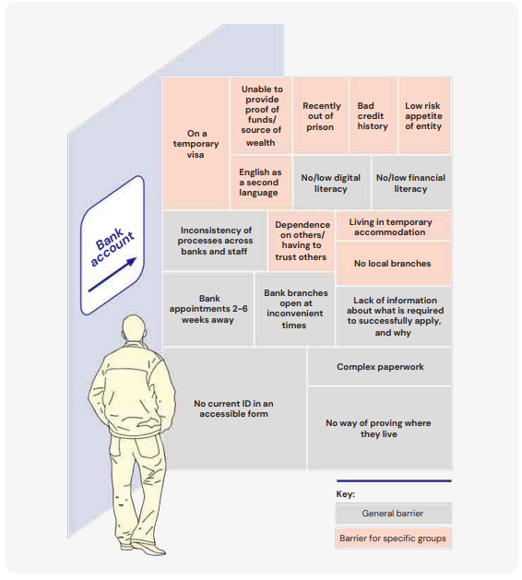
Figure 13. Barriers that can impact access to bank accounts for customers. Note: the size of each box does not reflect the relative scale or impact of each barrier.
Figure 13 chart text alternative: This figure highlights some of the barriers that can prevent people from opening bank accounts, such as waiting a long time for an appointment, not having current ID, and living in temporary accommodation.

Underlying drivers
Frontline staff describe a risk-averse stance to customer onboarding
Our findings suggest key factors in how onboarding requirements are interpreted and applied, which can impact access to banking. For example, frontline staff told us that blanket exclusion policies and a risk-averse approach can lead to declined applications, especially when some information is missing, or customers cannot advocate for themselves and the importance of having a bank account in their lives.
In addition, some frontline staff reported grey areas, or areas of uncertainty related to:
- who has the discretion or autonomy to approve applications for bank accounts in some scenarios;
- instances where applications need to be escalated to second or third tier teams;
- consistency around acceptable forms of identity and proof of address;
- how escalations are processed (and the timelines) for decision making.
Figure 14 below outlines what we have heard from frontline banking staff regarding decision making structures, and the relationship between 1st tier frontline banking staff, with 2nd tier risk and compliance teams, and the role of 3rd tier internal audit.
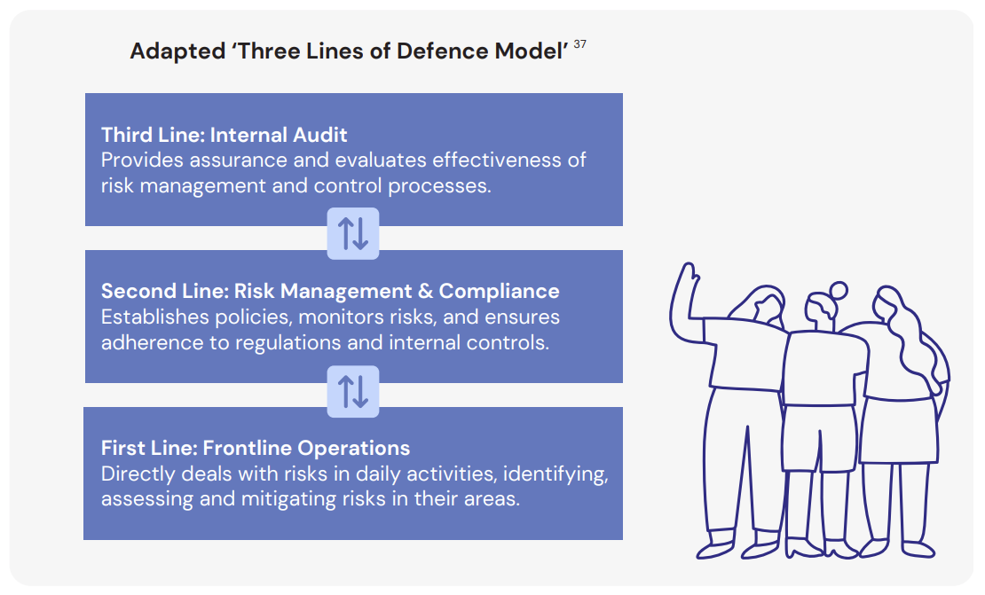
Figure 14. Decision making structures for customer onboarding appear to follow the ‘Three Lines of Defence Model’ for risk management.
Figure 14 text alternative: This figure highlights a way that banks appear to be managing customer onboarding risks based on the findings from the research. This diagram visualises three lines of defence, from front line operations who deal with customers, to second line risk and compliance teams, to third line audit and evaluation teams.
As part of this research, we found that frontline staff bring banks’ risk appetites to life in their daily interactions with customers. Their comments during the survey and qualitative interviews indicate how they interpret risk appetite. Our results suggest that a cautious approach to onboarding, limited discretion, and fear of audit and assurance checks can impact customer outcomes.
We also found inconsistencies in the training and support provided to frontline staff tasked with interpreting and applying risk appetite during customer onboarding:
- 46% of participants reported that they were not trained how to apply flexibility in the onboarding process or were not sure.
- 40% of frontline staff reported that they did not have policies in place or were not sure if there were policies in place to support flexibility and exceptions for onboarding customers.
- 76% of survey participants reported that they are encouraged to take a ‘cautious’ or ‘very cautious’ approach during customer onboarding, whereas 16% of respondents reported that they are encouraged take a ‘moderate’ approach.
Some of the participating frontline staff reported that they have limited support to apply exception processes or escalate complex cases for guidance or approvals. This can leave frontline staff feeling stuck, with some policies and practices being reported to discourage staff from opening accounts for some customers. The survey results also highlights regional inconsistencies in training on flexibility.
We note that there are some circumstances frontline staff reported as reasons to decline onboarding or apply additional restrictions, for example, customers who have been previously trespassed, violent, or fraudulent. However, our results suggest that the translation of risk appetite in managing customer onboarding risks extends beyond the original policy intent for customer due diligence processes. This creates unintended consequences for New Zealanders, constraining access to banking services.
Current onboarding practices did not appear to be performing well for many of the frontline staff and customers who participated in this research, highlighting opportunities for regulators and financial institutions to make improvements.
The issues highlighted by participants go beyond the control of frontline staff and customers, suggesting a systemic issue with opportunities for improvement across the system.
Overall, this research suggests people from many walks of life can face challenges in the onboarding process so the issue is more widespread than previous research suggests. The contributing factors are complex and go beyond the control of frontline staff and customers, suggesting a systemic issue with opportunities for regulators, financial institutions and other stakeholders to work together to improve.

Actions and next steps
There are opportunities for regulators and the banking sector to take action
This research raises questions around possible next steps that can be taken to promote efficient and inclusive customer onboarding. While this paper does not include detailed options analysis, this section identifies opportunities to mitigate friction points in customer onboarding that have been highlighted over the course of the research. We have grouped these into five themes (see Table 2 on next page).
We expect that key activities across these areas will help to improve outcomes for customers, frontline staff and broader society. The findings of this research reinforce the importance of legislative changes being led by the Ministry of Justice, including proposed changes to provide regulatory relief to financial providers in terms of changes to relax address verification requirements, and relaxing requirements to conduct enhanced scrutiny of customers that are trusts, including Māori trusts. Legislation to progress these changes was introduced to Parliament in 2024. The details of further changes to reduce the regulatory burden associated with CDD are currently under active consideration, with Cabinet decisions expected in Q2 2025.
Another mechanism for improving customer onboarding processes that is being considered by the Council of Financial Regulators is promoting the widespread availability of basic bank accounts, in line with recommendation 14 of the Commerce Commission Study into Personal Banking Services. Basic bank accounts (also known as basic transaction accounts, no-frill accounts, light KYC accounts, and simplified bank accounts) are designed to provide essential payment and transaction services to individuals who may have difficulty accessing traditional banking products. They are widely used in other countries. This includes people who are not able to provide proof of ID or address, people who may have poor credit history, older customers, people who are new to a country, those receiving social welfare support, young people and/or people who live in rural or remote areas.
Basic bank accounts are designed to be simple ‘money in and out accounts’, providing a narrowed set of features that enable payments and transactions and a simplified onboarding process. The Council of Financial Regulators will be releasing and seeking public input on a joint Issues Paper on Access to Basic Transaction Accounts in April 2025.
This report provides a foundation to guide future efforts, and changes that can improve customer onboarding processes.
We encourage financial regulators, the banking industry and the broader public to engage with the key findings of this research, and to work together on pathways to improve access to bank accounts as a first step for people to fully participate in the financial system.

Problem | Regulatory opportunities | Industry opportunities | Outcomes
Theme 1: Greater clarity of rules and consistency of practices
Results suggest variability across regions, branches and staff regarding approaches taken to onboard customers. | Explore regulatory guidance to provide clarity regarding exception-handling processes and highlight good practices for inclusive onboarding. | Review risk appetite frameworks, policies and processes for inclusive onboarding alongside frontline training and support | Greater clarity and awareness of actions entities and frontline staff can take to improve accessibility within existing compliance obligations.
Theme 2: Simplification
The requirements for opening a bank account can be too high for some customers, leading to financial exclusion. | Explore options for the widespread availability of basic transaction accounts as used in other countries. | Opportunities to pilot and implement basic transaction accounts that suit underserved customers | New Zealanders are able to participate in the financial system.
Theme 3: Extend monitoring
There is limited measurement and reporting on inclusive onboarding and account approvals/declines. | Develop, publish and monitor financial inclusion indicators related to access to bank accounts. | Explore measurement and internal reporting on access to bank accounts, including the number of customers declined a bank account. | Greater transparency and accountability around access to bank accounts.
Theme 4: Explore approaches for Māori customers and collectives
Māori participants reported problems for collective governance structures, limited cultural capability, and a historical and social context that can impact distrust. | Explore and promote customer onboarding practices that are responsive to the needs and aspirations of Māori customers and collectives. | Promote staff cultural awareness and capability, and consider improvements for onboarding Māori customers (such as charitable trusts). | Lower barriers for Māori customers and collectives in opening bank accounts.
Theme 5: Regional variability
Differences were observed in customer onboarding practices between Auckland and Wellington and other regions. | Explore access to bank accounts by region, and the links between customer onboarding practices and bank branch availability. | Consider regional variability in customer onboarding practices and staff training. | Both rural and urban New Zealanders have reasonable access to financial products and services that meet their needs.
Table 2. Opportunities to promote efficient and inclusive customer onboarding practices that emerged during this research.
Annex: Glossary
Concept | Description
Financial inclusion | RBNZ’s working definition of an inclusive financial system is one in which all New Zealanders have reasonable access to financial products and services that meet their needs.
Financial exclusion | This term is the inverse of financial inclusion, where people do not have reasonable access to financial products and services that meet their needs.
Customer onboarding | The customer onboarding process is a customer’s journey to open a bank account, from starting to consider their options, through to applying for a bank account, and getting an outcome on their application (approved or declined). This paper also uses the term ‘inclusive customer onboarding’ to refer to efforts that are taken to promote financial inclusion during the onboarding process, such as the effective use of exception handling processes.
Exception handling | Exception handling processes are designed to provide entities with an alternative pathway to onboard customers who may have genuine reasons for not being able to meet customer due diligence requirements. In order to comply with the Identity Verification Code of Practice (IVCOP), entities must have exception handling procedures in place, for example, enabling them to accept alternative forms of identity, relax address verification requirements in some circumstances, or provide urgent banking services to people through the use of delayed verification processes. It is a business decision for entities regarding how they carry out exception handling procedures.
Discretion | For the purposes of this research, discretion refers to how much autonomy a staff member has to vary an existing onboarding process, their ability to start an exception handling process, or their ability to help a customer to complete customer due diligence checks.
Flexibility | Flexibility is used in this report to refer to the ability of frontline staff to consider the circumstances of a customer, and tailor customer due diligence checks on a case-by-case basis for low-risk or vulnerable customers. For example, a flexible approach to onboarding could include the ability to use alternative forms of identification through a principles-based approach, rather than having very specific ID requirements such as only accepted a valid passport as proof of ID.
Customer exiting | Customer exiting is where a customer’s account is closed by their provider, terminating the banking relationship. A provider may exit a customer for a variety of reasons, such as how the person has been operating the account, regulatory requirements (e.g. failure to complete customer due diligence checks), bad credit, or violent or aggressive customer behaviour.
Bank account | A bank account refers to a New Zealand dollar financial account that meets peoples’ transactional needs (e.g. payments and withdrawals). It is worth noting that bank accounts are provided by a range of entities including credit unions, building societies and fintechs.
Basic transaction account | Basic transaction accounts are designed to provide basic banking services to individuals who may have difficulty accessing traditional banking services (such as people who are new to a country). Basic transaction accounts often have simplified onboarding processes, such as not requiring ID verification, but have controls in place to limit their ability to be used to finance crime.
Basic banking services | Basic banking services means the key retail and business services that bank customers typically rely on for transactions and economic life as per the RBNZ Outsourcing Policy BS11.
Banking sector | We use the terms ‘banking sector’ and ‘deposit taking sector’ interchangeably in this report to describe entities that provide basic banking services and/or engage in the business of taking deposits and lending. The term banking sector includes both bank and non-bank deposit takers, which reflects the new regulatory regime under the Deposit Takers Act which integrates the two currently separate regimes for registered banks and non-bank deposit takers into one.
Customer Due Diligence (CDD) | Customer due diligence is the process through which entities develop an understanding of their customers, and the AML/CFT risks they pose. Entities must conduct CDD when they establish a business relationship with a new customer, which includes verifying the identity of a customer (e.g. full name and address) and the nature or purpose of the customers business relationship.
Vulnerable customers | This term refers to people who, due to their personal circumstances, could be at greater risk of experiencing harm in their interactions with financial entities as per the CoFR Consumer Vulnerability Framework.
Unbanked | This term refers to individuals who do not have access to the mainstream financial system (e.g. banks or credit unions). People that are unbanked rely on alternative products and services to meet their financial needs (e.g. cash).
Underserved | This term refers to people who have limited access to financial products and services, and face barriers that can constrain their participation in the financial system (such as being geographically isolated).

Appendix 1: Research methodology
We framed our research around the ‘Water of System Change’ model. The Water of Systems Change lays out six interdependent conditions that typically play significant roles in holding a systemic, complex social problem in place (Figure 15).
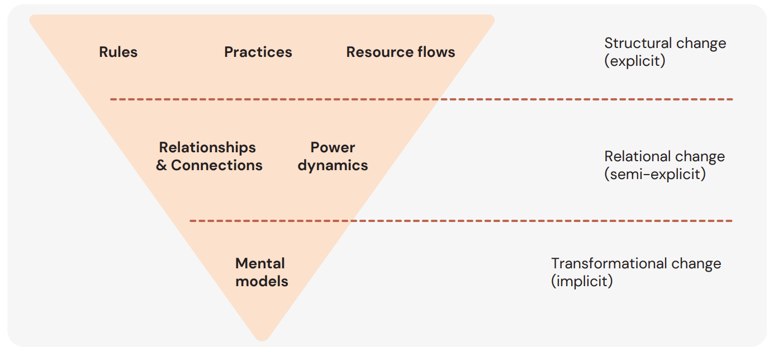
Figure 15. The Water of System Change model.
Figure 15 text alternative: This figure shows the three difference strands of the waters of change model, including structural change, relational change and transformational change.

Based on this model and the four over-arching research questions, we developed four areas to investigate: (Figure 16)

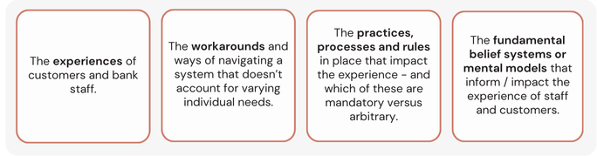
Figure 16. Four areas to be investigated within the research.
Figure 16 chart text alternative: This figure shows the four key research area that informed this research.
Sampling technique
The conclusions and observations are drawn from quantitative and qualitative data collected between May and October 2024. The high level approach undertaken in this research is outlined below in Figure 17.
The sample should not be treated as representative either of the cohort to which interviewees belong or of the general population.
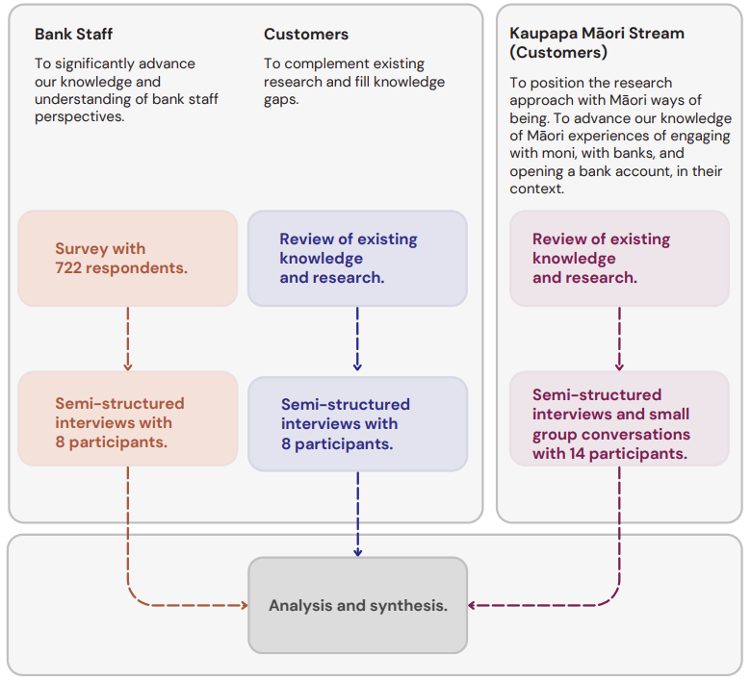
Figure 17. High level structure of the research components.
Figure 17 text alternative: This figure shows the three main strands of this research which were focused on learning from the experiences of frontline bank staff, customers, and a tailored kaupapa Māori stream. Under each strand, the diagram highlights the research techniques that were used to gather qualitative and quantitative data for analysis.

Qualitative techniques
To fully understand the experience of opening a bank account and fill in the gaps in the research, we used a mix of research methods to allow us to uncover stories from each target group.
Tables 3 and 4 summarise what we learned from a limited desktop review of the extent to which different population groups had featured in prior research conducted in New Zealand. This helped guide our choices about where to focus this research.
Bank staff research
There is limited public research on the staff experience of opening an account, the barriers they see their customers face, and the constraints they face themselves. We took a two-stage approach to build knowledge in this space:
Stage One - Survey
We created a short survey that investigated the customer onboarding process from a frontline banking perspective. This includes questions about the challenges that frontline staff face when opening bank accounts, the factors that enable them to successfully open peoples’ accounts, and how their organisation work to help those that struggle to open an account. This survey was sent to banks and non-bank deposit takers (NBDTs) by RBNZ, as well as banking associations such as the Tāwhia Māori Bankers Rōpū and the New Zealand Bankers Association (NZBA), who then circulated it within their organisations and networks. We had a total of 722 responses from across New Zealand. Of the 722 participants, the vast majority of participants worked for banks (681 participants), with fewer participants from non-bank deposit takers (building societies, credit unions and finance companies). The majority of participants were based in Auckland, and the majority of staff worked in physical bank branches, followed by call centres, online, hybrid work environments, and head office.
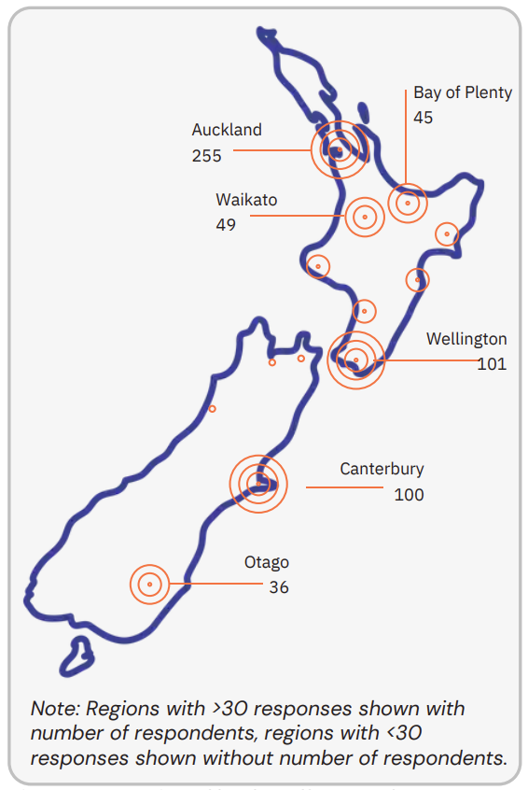
Figure 18. Location of bank staff respondents.
Figure 18 text alternative: This figure shows that the majority of participating bank staff were from Auckland (255 participants), Wellington (101 participants), and Canterbury (100 participants).
This survey enabled us to build up an evidence base from front line employees across the country, and enabled us to recruit for participants for the second part of the approach.
Stage Two – Interviews
Following the survey we identified front line banking staff who had unique perspectives in the survey and who had indicated an interest in participating in the interviews. In these interviews we dug deeper into their responses to uncover stories, understand their decision-making authority, their mental models, and belief systems. We held 8 semi-structured interviews (between 30 -60 mins) with survey respondents (bank staff) in the following roles:
- 2 personal bankers.
- 3 consultants.
- 2 managers.
- 1 assistant bank manager.
The staff who participated in the interviews were from across the country: Auckland, Taranaki, Wellington, Nelson, and Canterbury.
Customers research
This part of the research was undertaken in two streams, a general stream, and a stream taking a kaupapa Māori approach to engage with Māori participants.
General stream
We conducted 8 semi-structured interviews with individuals and entities who have struggled to open an account (underserved customer segments). These interviews complemented research conducted in previous studies and aimed to fill knowledge gaps, and we scanned literature to understand existing work and determine where to focus our efforts.
We spoke to people with lived experience, as well as organisations that could speak on behalf of others.
This meant that we primarily learned about the experiences of:
- youth, particularly those in state care,
- migrants,
- older people,
- small and medium enterprises (SMEs),
- virtual asset service providers (VASPs), and
- trusts and not-for-profits.
We conducted semi-structured qualitative interviews with individuals, small businesses, trustees, Virtual Asset Service Providers, and those operating a business in new or emerging industries related to fintech, who had experienced difficulty opening a bank account, or could speak to the difficulties faced by users of their services or those they support.
These interviews once again helped us understand the experience at a deeper level to uncover not only the barriers and enablers, but also their underlying beliefs and mental models. We used a targeted approach, asking participants to suggest others, to help us find more people for the study. This involved reaching out to existing contacts and organisations who referred us to people with similar experiences, which helped us connect with a larger group of participants.
We also paid particular attention to the experiences of whānau Māori and Māori businesses by establishing a parallel Kaupapa Māori research stream.
Kaupapa Māori stream
Within the overall project, a standalone tailored kaupapa Māori workstream was established to understand Māori experiences of opening a bank account, and place these experiences in a broader context.
The overarching research question guiding the Kaupapa Māori research stream was:
What are Māori attitudes, beliefs, experiences and behaviours towards moni / banks / bank accounts / opening a bank account?
Within the kaupapa Māori stream, it is important to understand how the isolated experience of opening a bank account fits within their broader social and cultural context for Māori today. This takes into account any pre-existing relationships, beliefs or attitudes that might exist in relation to bank accounts, banks, and money more generally. Because of this, the research engagements began with broader considerations and then cascaded down to the event of opening a bank account, including barriers and enablers, so that a full picture could emerge.
The research consisted of two types of research engagement:
- Small group conversations. In this format, the relationship and exchange between participants is important, and so participants with prior relationships with each other were identified. The conversations were free-flowing, with the researcher asking questions from time to time and encouraging participants to share their experiences and views.
- Individual interviews. In this format, the relationship and exchange between the participant and the researcher is important. The conversations were semi-structured, with the researcher asking questions, responding to the responses and asking additional questions based on the responses.
The researchers were particularly interested in understanding different perspectives between those who live in cities and those who live rurally, different generational perspectives (e.g. tamariki compared to adults), as well as the perspectives of whānau compared to leaders of iwi trusts.
In total, 14 people contributed their perspectives to this research stream. The group conversations and individual interviews were undertaken in both Te Reo Māori and English, reflecting the preferences of participants. Group conversations with tamariki also involved their parents or other whānau members.
Analysis
Thematic analysis was undertaken to identify key findings across the different conversations. Thematic analysis, and coding of responses helped the researchers to identify key barriers to opening bank accounts, the drivers of those barriers, and opportunities for financial regulators and the banking sector.
We used data analysis software to support us in processing the data from the different research methods and then used principles of thematic analysis to guide our collaborative generation of the themes, insights and recommendations.
Limitations
We interviewed individuals, business owners and trustees who had experience struggling to open an account, or who had directly supported others who struggled to open accounts. These views were expressed in confidence, and no identifying information regarding the participating people or entities has been included. Statistical analysis has not been undertaken, and the results of this survey should not be extrapolated beyond those who directly participated in the research.

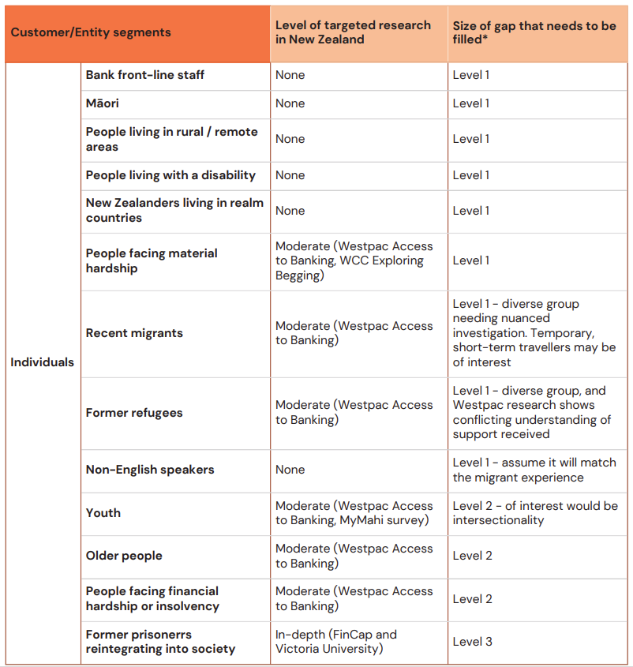
Table 3. Customer segments and the extent to which these different population groups have featured in prior research (based on a limited desktop review of New Zealand-specific research). *Note: Level 1 = large knowledge gap, Level 2 = medium knowledge gap, Level 3 = small knowledge gap.
Table 3 text alternative: This table shows the size of the research gap that was identified for different customer segments. The table highlights that there was a large knowledge gap in terms of understanding the experiences of non-english speakers, recent migrants, people facing material hardship, New Zealanders living in realm countries, people living with a disability, people living in remote/rural areas, Māori, and frontline bank staff.

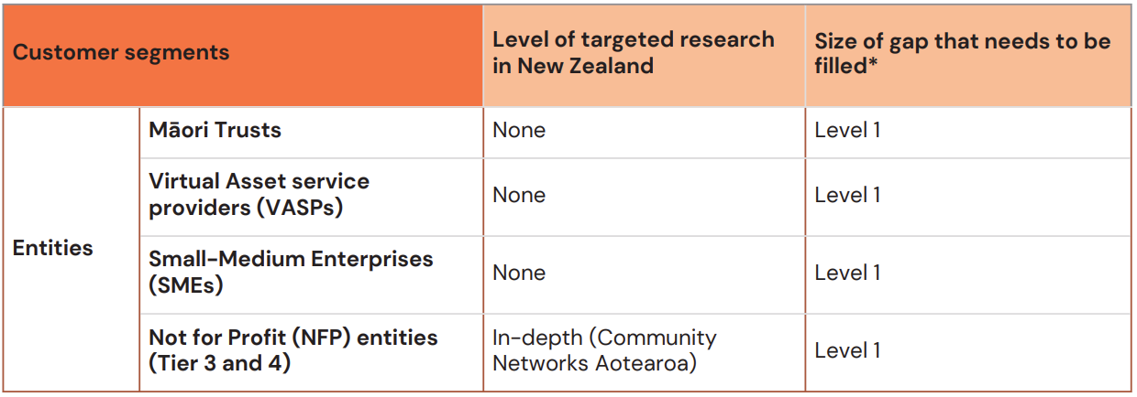
Table 4. Entity segments and the extent to which these different entities have featured in prior research (based on a limited desktop review of New Zealand-specific research). *Note: Level 1 = large knowledge gap, Level 2 = medium knowledge gap, Level 3 = small knowledge gap.
Table 4 text alternative: This table shows the size of the research gap that was identified for entities. This table highlights that there is a large knowledge gap for Māori trusts, virtual asset service providers, small and medium sized enterprises and not-for-profit entities.

Ethical practice
To ensure an ethical process, ThinkPlace New Zealand’s research ethics principles were applied, in particular:
- We do no harm. We balance our approach to get information with a conscious regard for research participants’ safety and wellbeing. As there is existing research into the experience of customers trying to open an account, we needed to be aware of who has engaged on this topic before, build on the existing research and not contribute to engagement fatigue.
- We are aware of and respect social and cultural sensitivities in dealing with research participants. We seek advice when going into particular communities and observe and respond to research participants’ social cues.
- We recognise the rights of Māori as tangata whenua, indigenous people, of Aotearoa / New Zealand and endeavour to engage meaningfully with the spirit of Te Tiriti o Waitangi.

Appendix 2: Research questions
Survey questions (bank staff)
How often are you unable to open an account for someone? (Figures 3 & 8).
Multiple Choice:
- Never/can’t recall.
- Very rarely (less than once a year).
- Rarely (once every 6-12 months).
- Sometimes (once every 1-6 months).
- Often (every month).
- Very often (weekly).

Please indicate how often you have experienced the following to be barriers to someone trying to open a bank account. (Table 1).
Rating Scale - never/can’t recall, very rarely (less than once a year), rarely (once every 6-12 months), sometimes (once every 1-6 months), often (every month), very often (weekly):
- Lack of ID.
- Lack of proof of address.
- Lack of access to a branch.
- Complexities of paperwork (i.e. trusts, businesses, entity relationships).
- Proof of funds requirements.
- Risk profile issues (including AML/CFT risk).
- Language barrier or not having information in their preferred language.
- Comprehending/understanding terms (financial literacy).
- Bad credit history.
- Being trespassed from banks.
- Acting on behalf of others.
- Criminal record.
- Needing extra time to process.

What level of discretion do you have to apply flexibility to onboard customers? (Figure 4).
Multiple Choice:
- No discretion.
- Limited level of discretion.
- Moderate level of discretion.
- High level of discretion.

What approach are you encouraged to take during customer on-boarding? (Figures 5 & 6).
Multiple Choice:
- Very lenient.
- Lenient.
- Moderate.
- Cautious.
- Very cautious.
- Not sure.

In which location do you work? (Figures 6, 7, & 8).
Multiple Choice:
- Northland.
- Auckland.
- Waikato.
- Bay of Plenty.
- Gisborne.
- Hawke’s Bay.
- Taranaki.
- Manawatū-Whanganui.
- Wellington.
- Tasman.
- Nelson.
- Marlborough.
- West Coast.
- Canterbury.
- Otago.
- Southland.
- Tokelau.
- Cook Islands.
- Niue.
- Other.

Were you trained on how to apply flexibility in the boarding process? (Figure 7).
Multiple Choice:
- Yes.
- No.
- Not sure.

Based on your experience, which groups of people have been most likely to have difficulty opening an account? (Figure 9).
Multiple Choice:
- People living in rural/remote areas.
- People facing hardship.
- Youth (under the age of 18).
- People facing insolvency or bankruptcy.
- Māori.
- People living with a disability or impairment.
- Elderly.
- Trusts and not-for-profits.
- Business owners.
- Non-English speakers.
- Recent migrants.
- Former refugees.
- Other.

What does your organisation do to support customers into banking? (Figure 11).
(Free-text answers).

What enables/supports you to apply flexibility? (Figure 12).
Multiple Choice:
- I’ve been well trained.
- I have lots of experience.
- My manager is supportive.
- I have good resources I can refer to.
- Other.

Your ideas: What would you change to improve the process of opening a bank account for individuals or entities? Share as many ideas for improvement as you would like. (Table 2).
(Free-text answers).

Interview topics
Bank staff interviews
- Experiences when opening bank accounts for customers.
  - Including barriers and enablers.
- Opinions about the rules bank staff must follow.
- Opinions about banks’ customer onboarding policies and procedures.
- Ideas for improving the customer onboarding process.

Customer interviews
- Experiences when opening bank accounts.
  - Including barriers and enablers.
- Impacts when it is easy to access banking.
- Impacts when it is difficult to access banking.
- Impacts of having and not having a bank account.
- Suggestions for improving the onboarding experience.

Kaupapa Māori stream (customers)
- The impact of historical and social context on Māori experiences of opening bank accounts.
- The relationships between bank accounts and collective wellbeing.
- Barriers and enablers for Māori opening bank accounts.

Deposit Takers Act - Reserve Bank of New Zealand (Te Pūtea Matua)
Our Financial Policy Remit - Reserve Bank of New Zealand (Te Pūtea Matua).
The relationship between financial inclusion and financial stability - Reserve Bank of New Zealand (Te Pūtea Matua)
Our Approach to Financial Inclusion - Reserve Bank of New Zealand (Te Pūtea Matua)
Westpac-NZ-Access-to-Banking-in-Aotearoa-Report.pdf
Disability and Inclusion in Banking (Westpac NZ)
Written Submission: MyMahi Petition (July 2023)
FinCap-Paying-the-Price-Final-25-June.pdf
Community Networks Aotearoa (2023)
KYC-Innovations-Financial-Inclusion-Integrity-Selected-AFI-Member-Countries.pdf (2019); Action 1 | Digital Finance Inclusion (World Bank); Mexico’s Tiered KYC: An Update on Market Response (CGAP)
KYC-Innovations-Financial-Inclusion-Integrity-Selected-AFI-Member-Countries.pdf (2019)
Public Consultation on AML/CFT and Financial Inclusion – proposed changes to FATF Standards (2024)
Assisting customers who don’t have standard forms of identification (AUSTRAC)
RBNZ (2024). Financial Inclusion Thematic Review.
Statistics New Zealand. (2024). New Zealand business demography statistics.
RBNZ Cash system data collection reported 17 December 2024.
Cash use (H3) - Reserve Bank of New Zealand (Te Pūtea Matua)
See for example, Last bank left in South Wairarapa closes (NZ Herald)
Cash use (H3) - Reserve Bank of New Zealand (Te Pūtea Matua)
Government announces final changes to the CCCFA Regulations (Ministry of Business, Innovation & Employment)
Foreign Account Tax Compliance Act (Inland Revenue)
Anti-Money Laundering and Countering Financing of Terrorism Act 2009 No 35 (as at 05 April 2023), Public Act Contents – New Zealand Legislation
See for example, Review of the AML/CFT Act (2021); and Personal Banking Services Market Study: Westpac NZ's response to the draft report (2024)
See for example: Government to provide significant regulatory relief for business (Beehive.govt.nz | 13 Oct 2024); and Minister welcomes business view on AML (Beehive.govt.nz | 29 Oct 2024)
Interest.co.nz (June 2016)
Interest.co.nz (March 2023)
Interest.co.nz (December 2024)
Westpac NZ Access to Banking in Aotearoa, 2023; Petition of MyMahi, 2023; Community Networks Aotearoa Better Banking, 2023; Issues Prisoners Face Around Access to Banking, Stace & Sibanda, 2023; Commerce Commission Wānanga (Feb 2024); te Arotahi Series Paper (March 2020)
See for example, Westpac-NZ-Access-to-Banking-in-Aotearoa-Report.pdf
See for example, Written Submission: MyMahi Petition (July 2023); and Kiwibank-Submission-on-Market-study-into-personal-banking-services-Draft-report-18-April-2024.pdf
Qualitative research is a type of research that aims to gather and analyse descriptive data to understand peoples’ attitudes, experiences, beliefs and behaviours.
Quantitative research focuses on gathering numerical data (numbers) and analysing trends, averages and relationships between variables.
The RBNZ’s work on financial inclusion indicators aims to fill this gap in having a population representative estimate of the total number of people in New Zealand without a bank account, disaggregated by factors such as age, ethnicity, region, highest qualification and household wealth.
Westpac-NZ-Access-to-Banking-in-Aotearoa-Report.pdf
Virtual asset service providers are digital online platforms that facilitate transfers and exchanges, such as money remitters, mobile money providers or cryptocurrency traders. Source: AML-CFT Virtual Asset Service Providers (dia.govt.nz)
Community Networks Aotearoa _ Better Banking 2023 Report.pdf
Logic Manager (2023)
Financial Inclusion (Council of Financial Regulators)
Basic savings account vs no frills account (BankBazaar.com)
Light KYC (FaisalKhan.com)
Payment Systems Worldwide (The World Bank, 2023)
AML-CFT Frequently Asked Questions for DIA Reporting Entities (dia.govt.nz)
Principles-for-Exiting-a-Customer.pdf
Closing accounts (Banking Ombudsman Scheme)
2017 09 19 - Final BS11 redraft (rbnz.govt.nz)
Payment Systems Worldwide (World Bank)
Final BS11 redraft (2017 09 19)
AMLCFT-Customer-Due-Diligence-Companies.pdf
CoFR-Consumer-Vulnerability-Framework-April-2021.pdf
The Water of Systems Change, by Kania, Kramer, & Senge. (2018).

