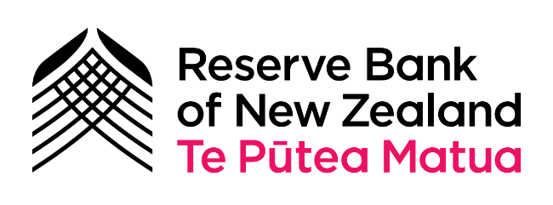
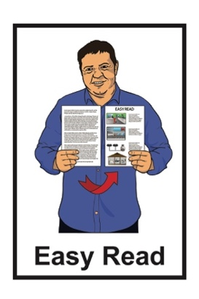

Keeping cash local:

Part 2 – survey
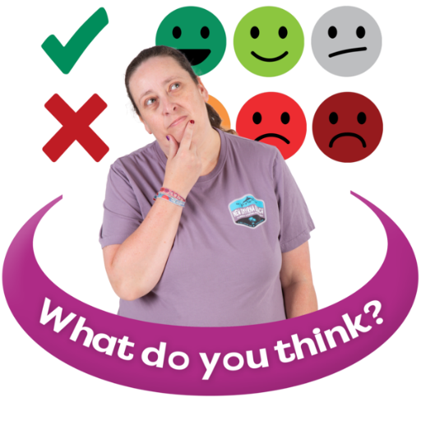
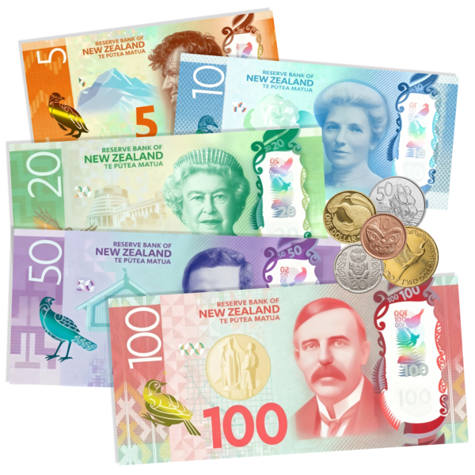

Published: May 2026

About this Easy Read

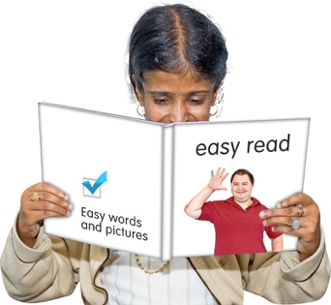
This Easy Read is a survey from the Reserve Bank of New Zealand –
Te Pūtea Matua.

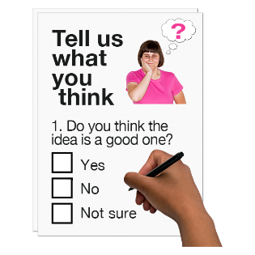
A survey is a list of questions that you can answer.

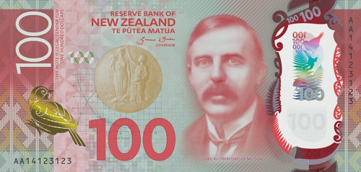
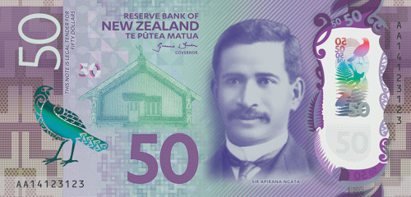
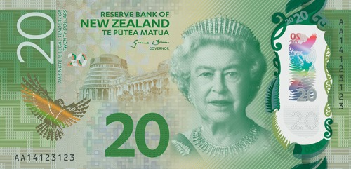
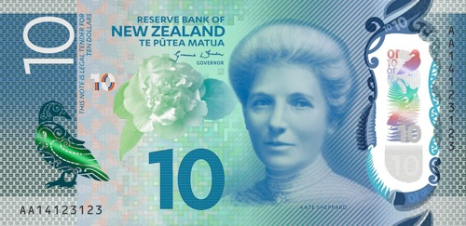
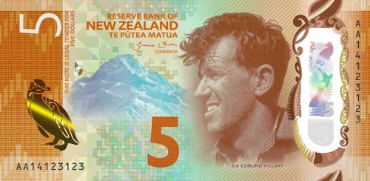
The Reserve Bank of New
Zealand – Te Pūtea Matua is the part of the Government that looks after:
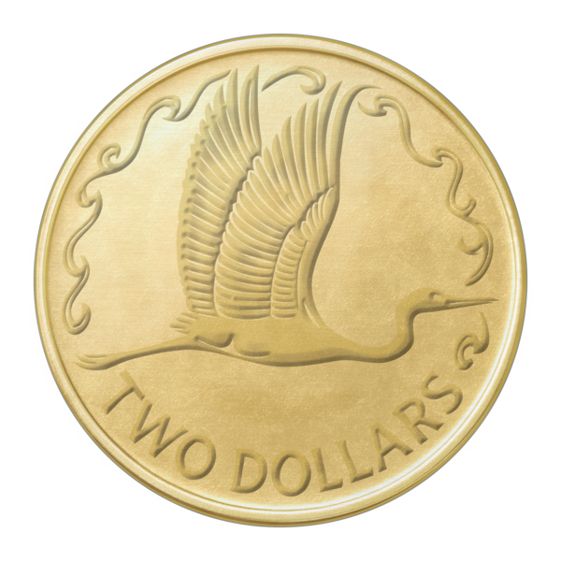
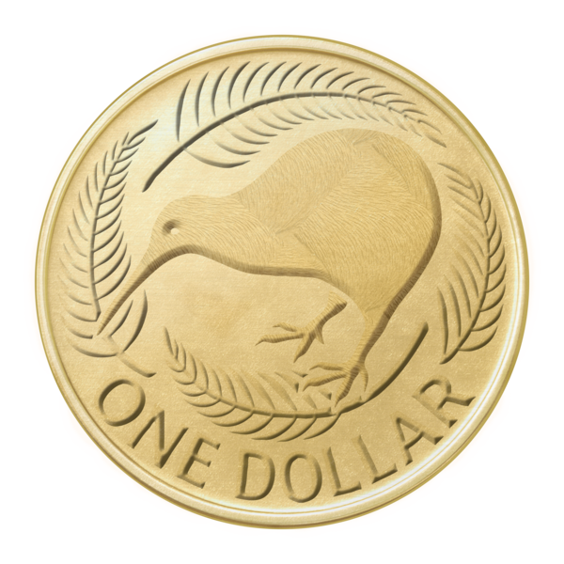
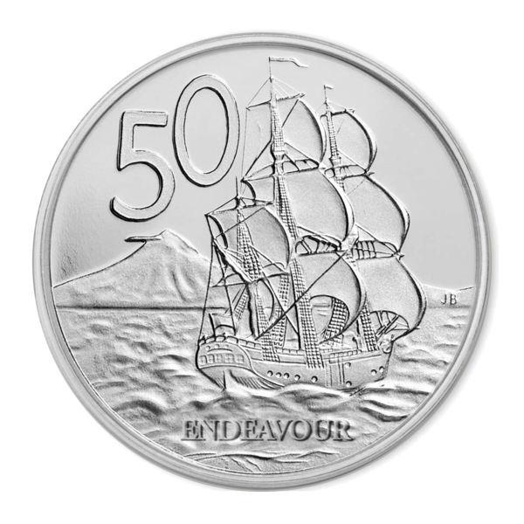
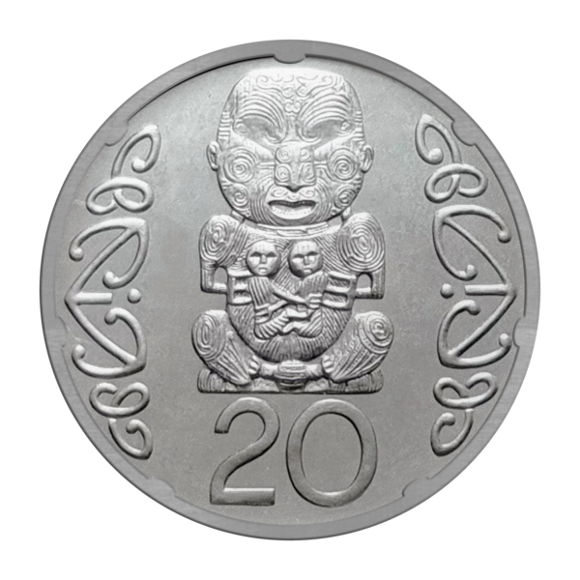
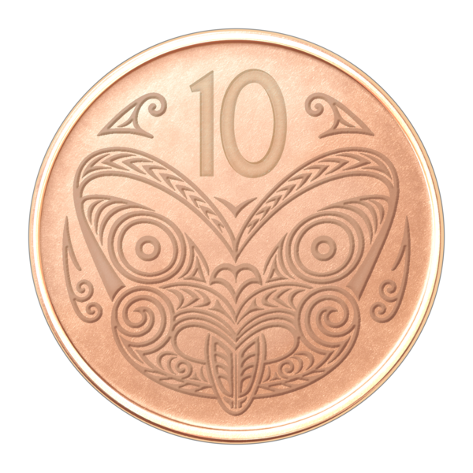
notes
coins
things to do with money in Aotearoa New Zealand.
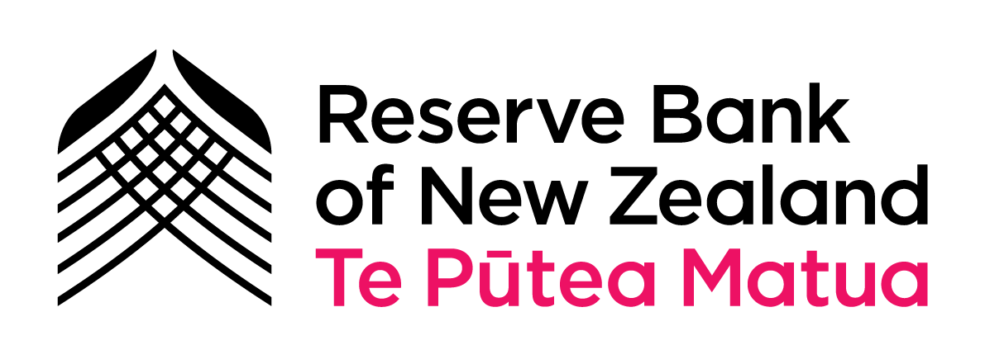
In this Easy Read the Reserve Bank of New Zealand – Te Pūtea Matua will be called the Reserve Bank.


The words we / us in this Easy Read mean the Reserve Bank.

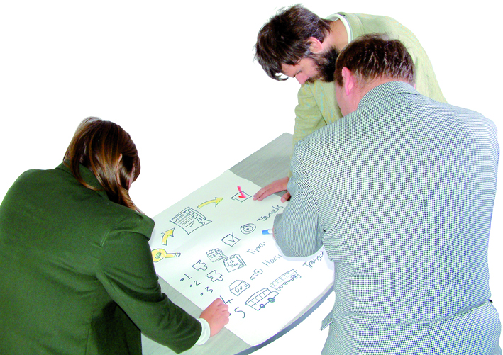
We have come up with a
proposal to make a cash services standard for banks in New Zealand.


Here a proposal is an idea that would be good to do.

Cash means money that is:
notes
coins.

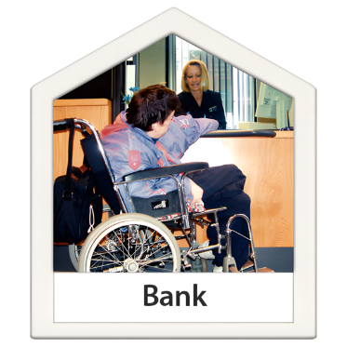
Here cash services are ways that support you to:
deposit / put cash into your bank account
withdraw / take cash out of your bank account
change cash into different:
- notes
- coins.
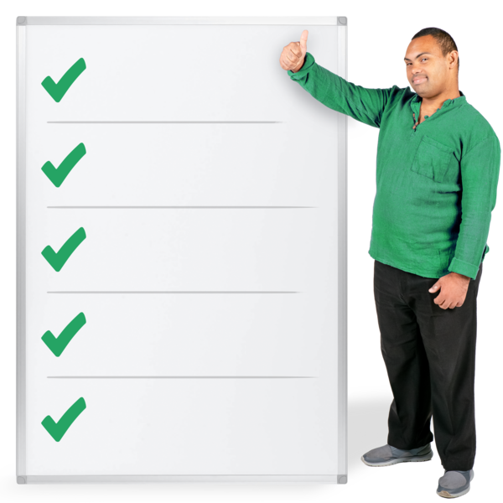

Here a standard is a set of rules that makes things run well for everyone.

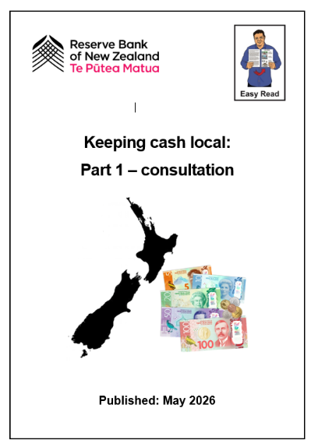
You should read the Easy Read Keeping cash local: Part 1 –
consultation before you do this survey.

Part 1 tells you about some of the:
words in this survey
ideas in this survey.

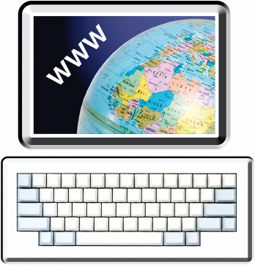
You can read the Easy Read Keeping cash local: Part
1 – consultation at this website:

www.rbnz.govt.nz/cashfeedback

About the survey

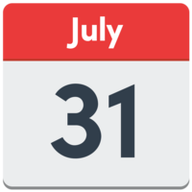
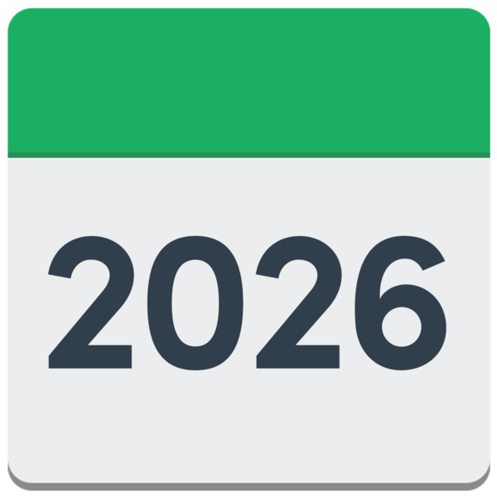
Please give us your feedback by
31 July 2026.
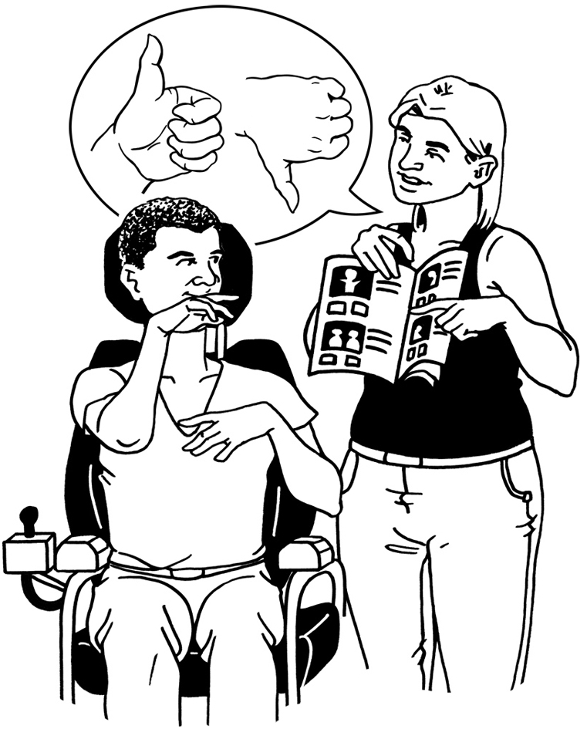

What you say will help change the future of cash services in Aotearoa New Zealand.


You can choose which questions in this survey you want to answer.

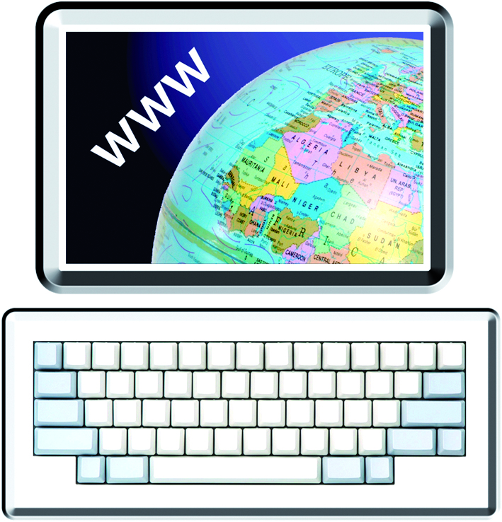
You can do the survey at this website:

www.rbnz.govt.nz/cashfeedback

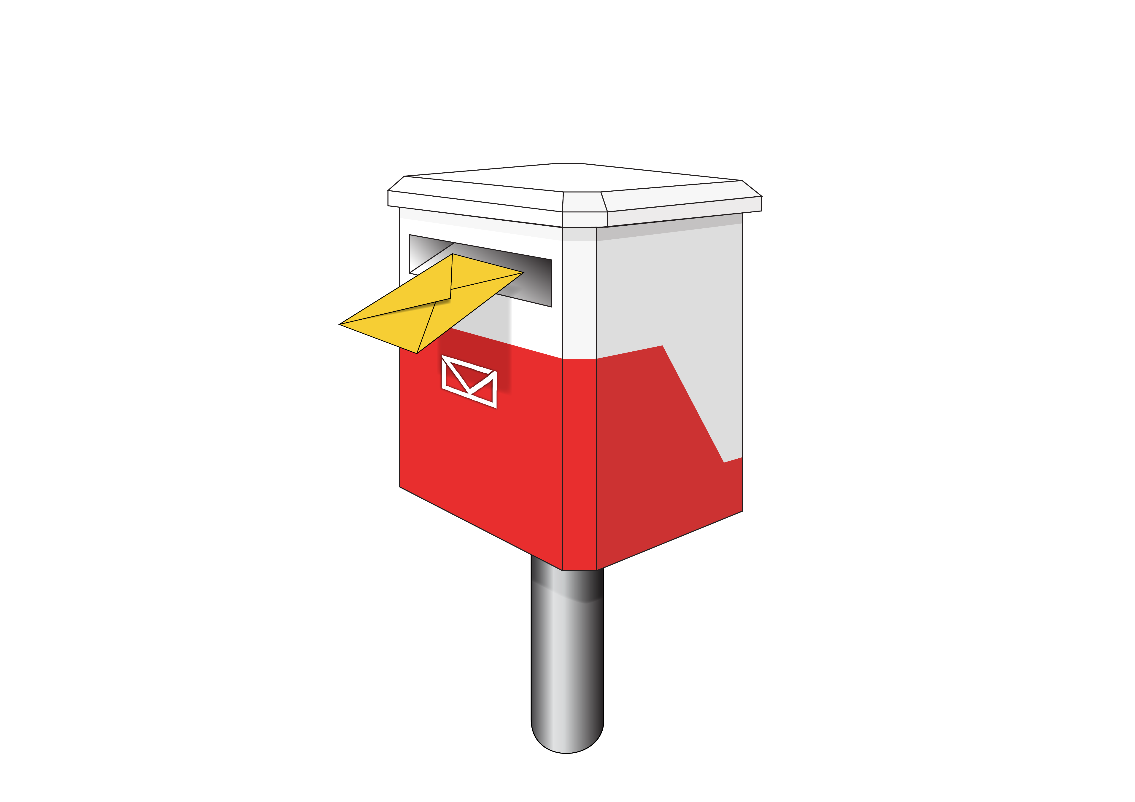
You can send this form when it is filled in by post to:

Future of Money and Payments

Money and Cash

Reserve Bank of New Zealand

PO Box 2498

Wellington 6140

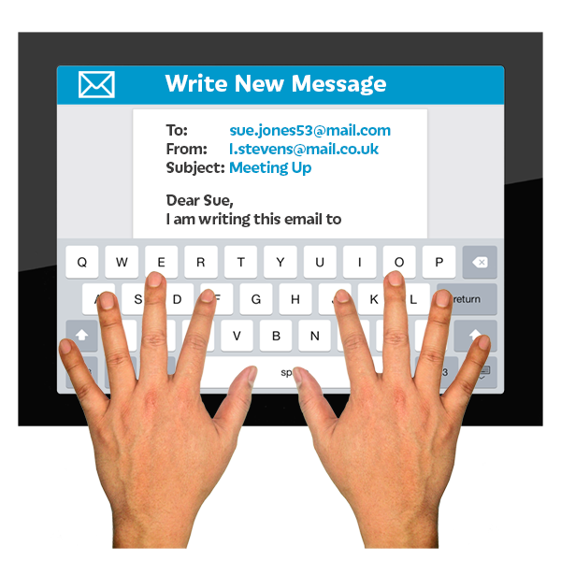
You can also send written feedback by email to:

futureofmoney@rbnz.govt.nz

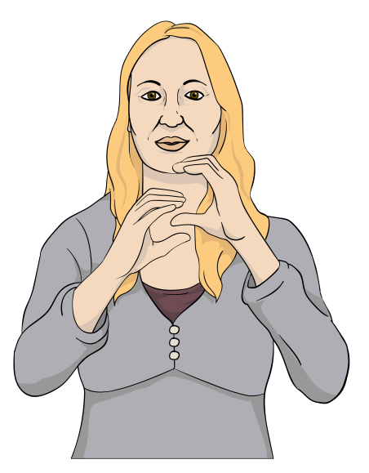
You can also give your feedback in New Zealand Sign Language / NZSL at the NZSL Direct website:

www.nzsl.direct/rbnz
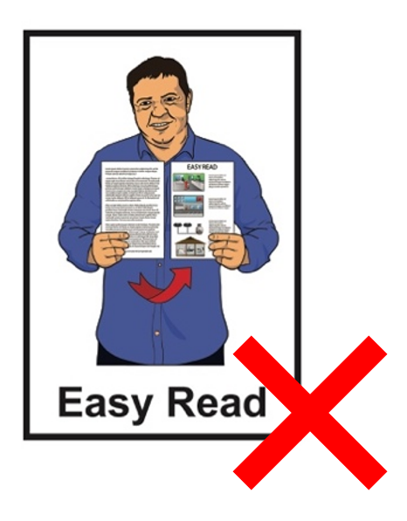

This website is not in Easy Read.
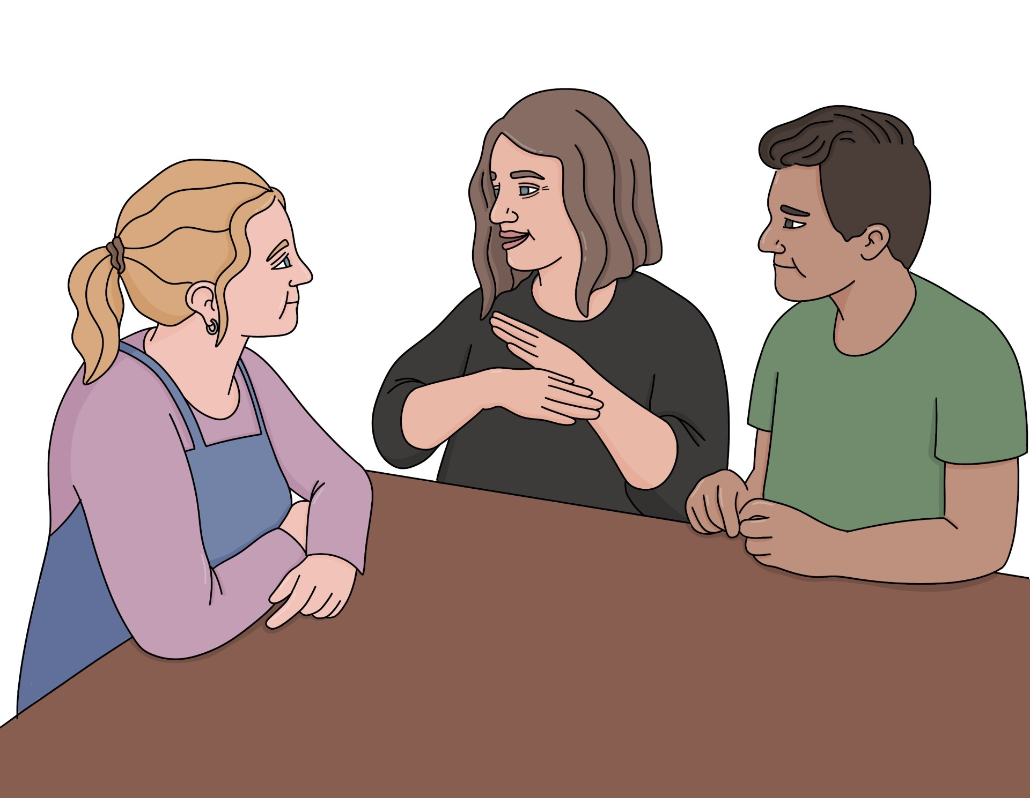
After you record your feedback in New Zealand Sign Language / NZSL it will be:
translated into English for
free / no cost
sent to the Reserve Bank.

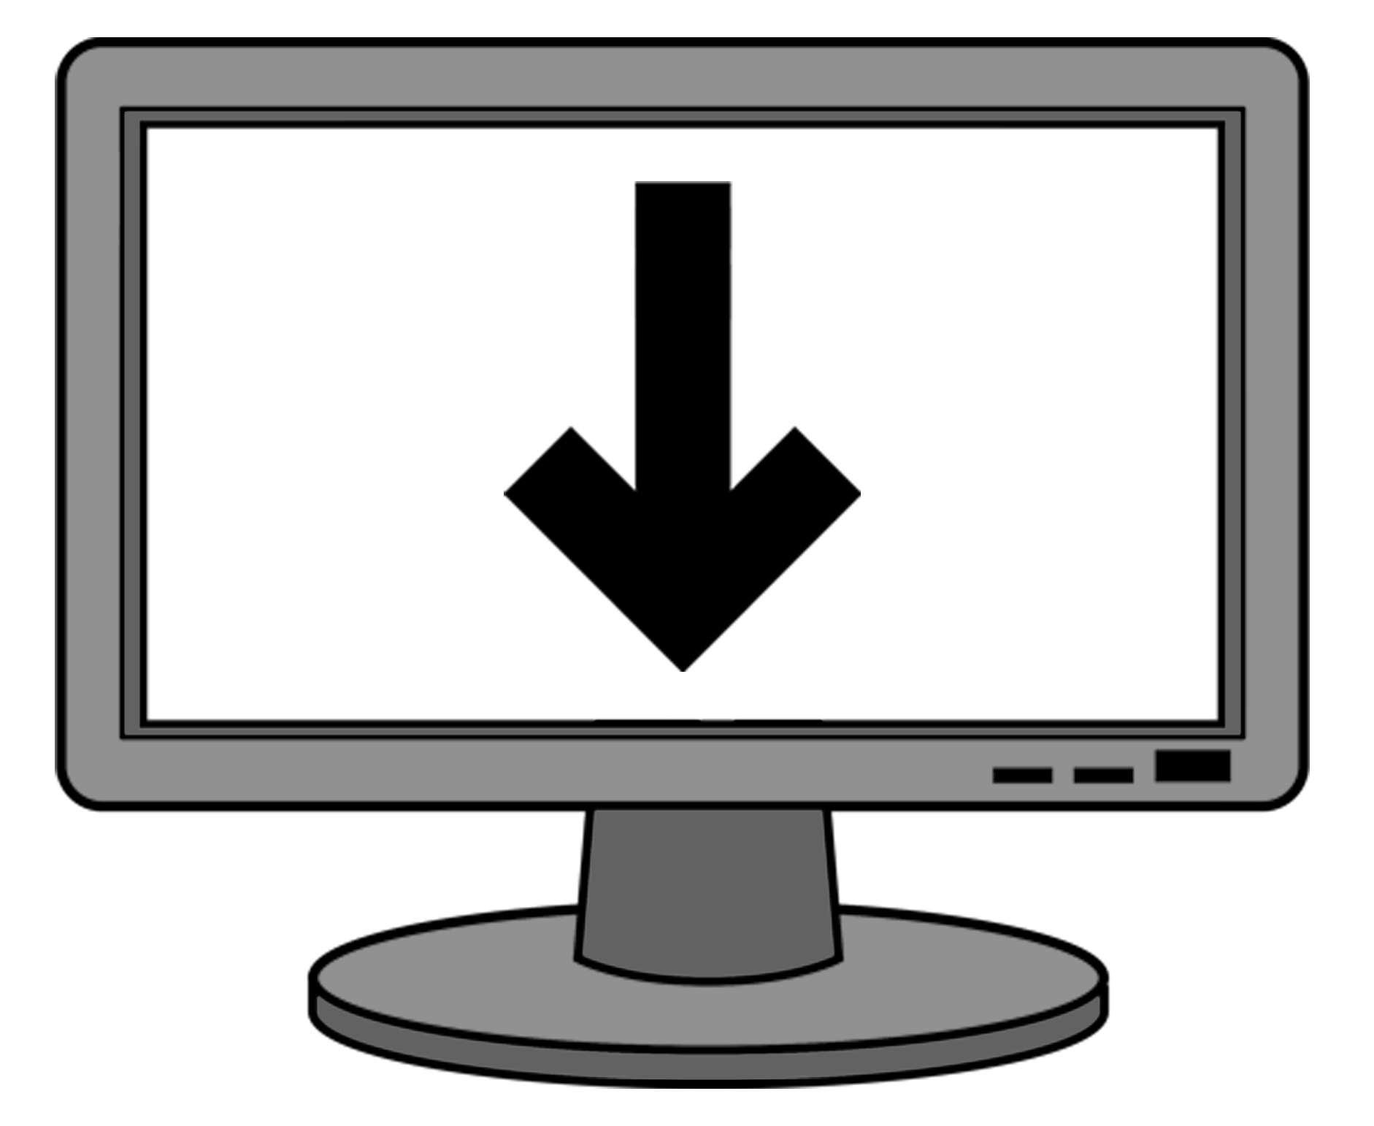
You will also be sent a copy of the translation.

About cash services you can get now

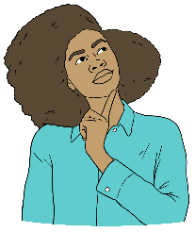

How happy are you with the cash services where you live?

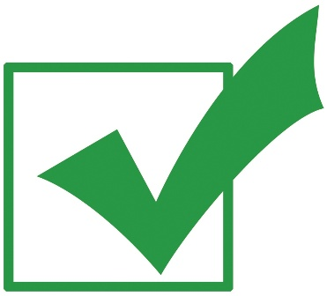
Tick the box that is right for you.

very unhappy – services are very bad

a bit unhappy – services are not good

not unhappy or happy – services are okay

a bit happy – services are good

very happy – services are great

I do not know.

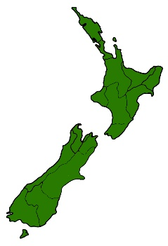
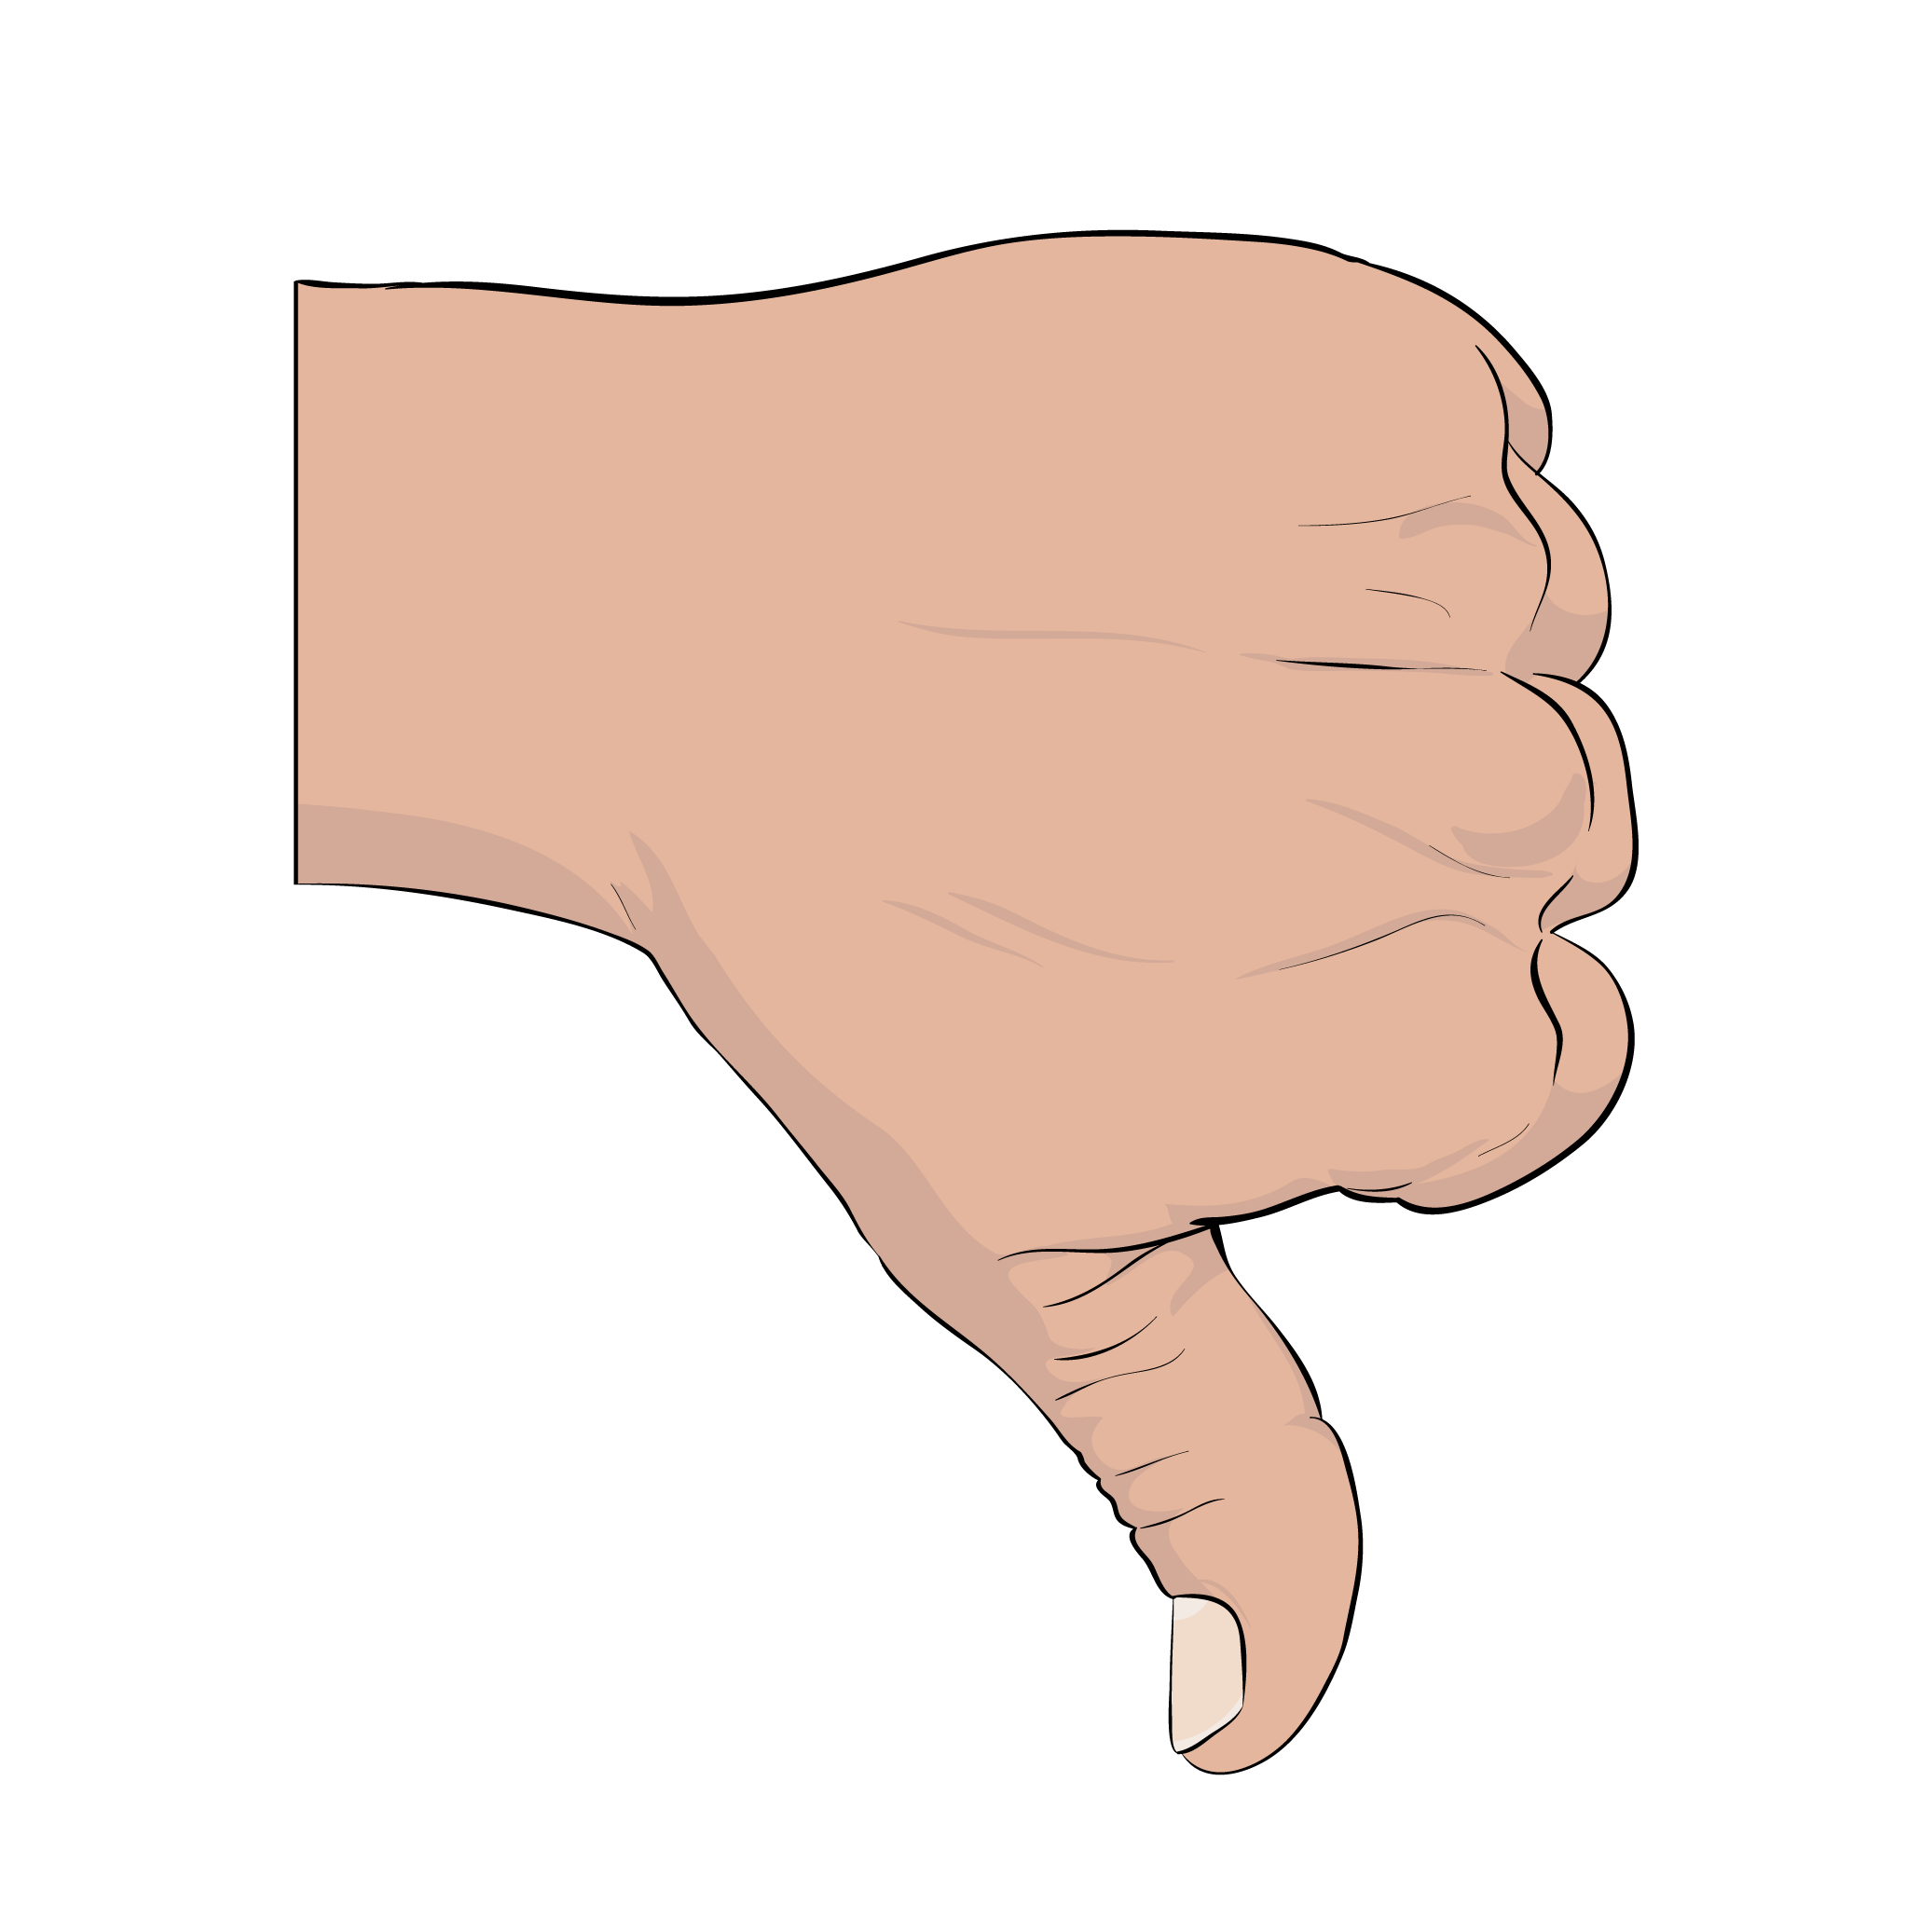

How happy are you with the cash services in all of Aotearoa New Zealand?

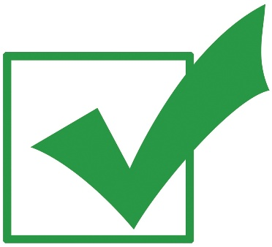
Tick the box that is right for you.

very unhappy – services are very bad

a bit unhappy – services are not good

not unhappy or happy – services are okay

a bit happy – services are good

very happy – services are great

I do not know.

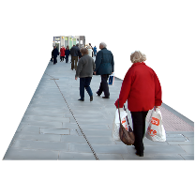
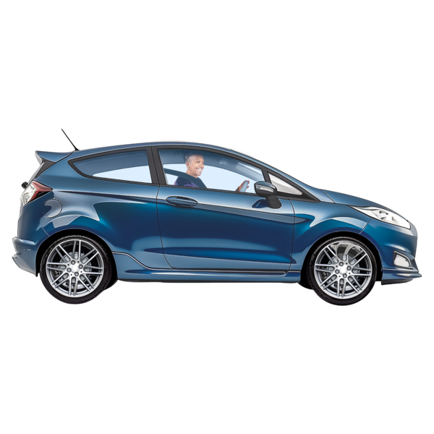
How important is how far you need to travel to use a cash service?

Tick the box that is right for you.

not important at all

not very important

I do not mind

a little bit important

very important

I do not know.

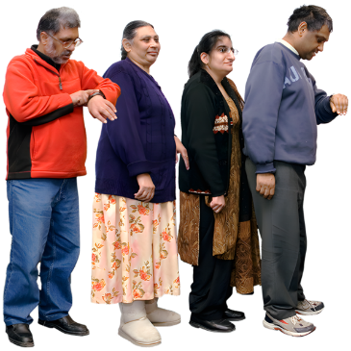
How important is how you long you have to wait in a queue to use a cash service?

Tick the box that is right for you.

not important at all

not very important

I do not mind

a little bit important

very important

I do not know.

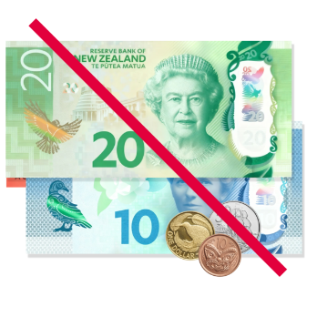
How important is it that the cash service is free to use?

Tick the box that is right for you.

not important at all

not very important

I do not mind

a little bit important

very important

I do not know.

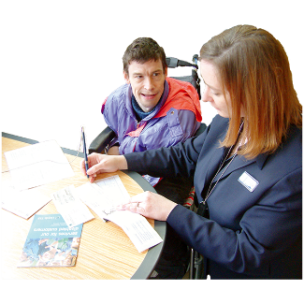
How important is it having staff who can support you to use cash services?

Tick the box that is right for you.

not important at all

not very important

I do not mind

a little bit important

very important

I do not know.

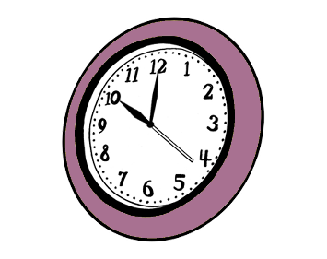
How important is it you can use the service during business hours?

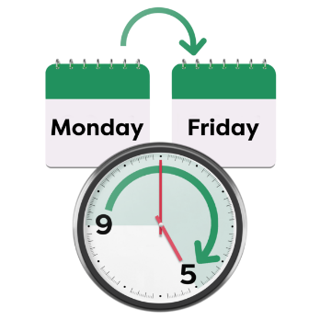
Business hours are usually:
Monday to Friday
9 am to 5 pm.

Tick the box that is right for you.

not important at all

not very important

I do not mind

a little bit important

very important

I do not know.
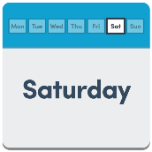
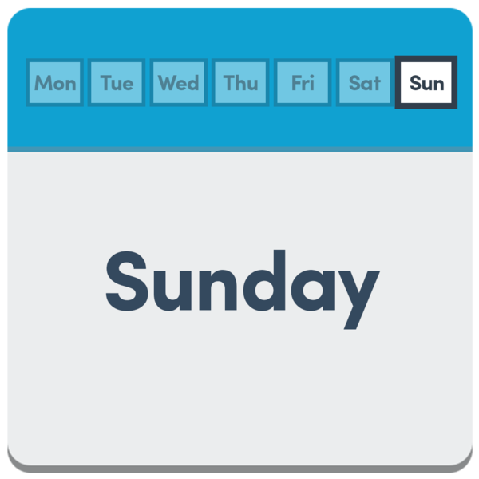
How important is it you can use the service outside business hours including:
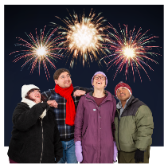
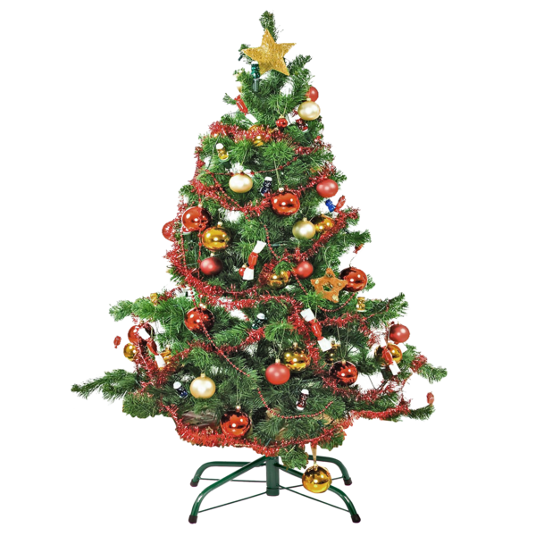
weekends
public holidays?

Tick the box that is right for you.

not important at all

not very important

I do not mind

a little bit important

very important

I do not know.

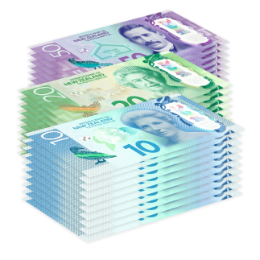
Are there any other things about how you use cash services that are important to you?

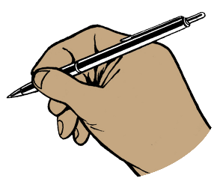
Tell us what you think in the box below.

About the proposed cash services standard

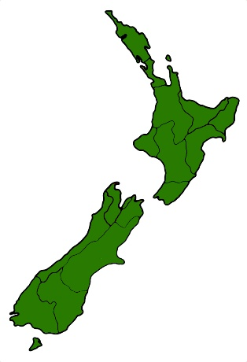
How much do you agree with the sentence below?

Aotearoa New Zealand needs a cash service standard.

Tick the box that is right for you.

I disagree a lot

I disagree a bit

I do not mind

I agree a bit

I agree a lot

I do not know.

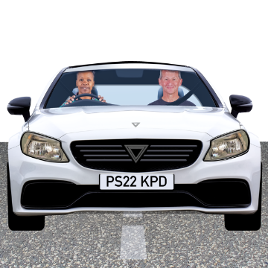
How much do you agree with the sentence below?

To get cash services people should only have to travel:
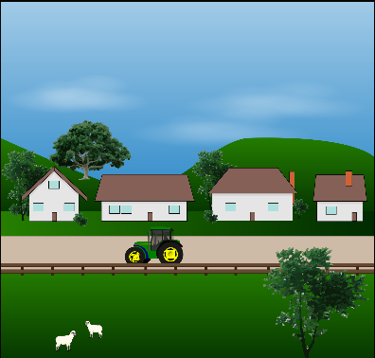
15 kilometres if they live in a rural area / out of town
30 kilometres if they live in a remote area / a long way out of town.

Tick the box that is right for you.

I disagree a lot

I disagree a bit

I do not mind

I agree a bit

I agree a lot

I do not know.

How much do you agree with the sentence below?

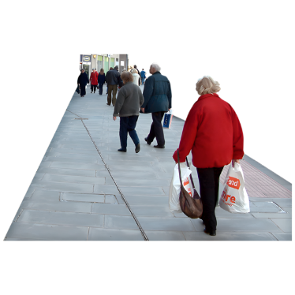
To get cash services people should only have to travel 3 kilometres if they live in an urban area.

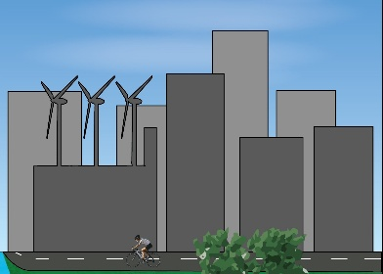
Here an urban area is a place with 1 thousand or more people living in it.

Tick the box that is right for you.

I disagree a lot

I disagree a bit

I do not mind

I agree a bit

I agree a lot

I do not know.

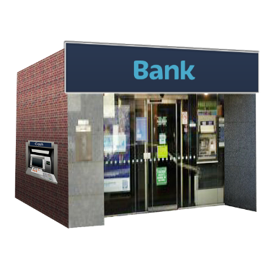
How much do you agree with our proposal to have more than 2 cash service sites for every 10 thousand people?

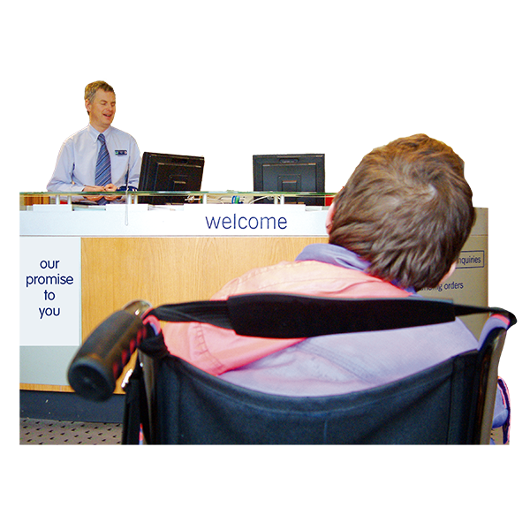
Here a cash service site means where all the banks would do their services in 1 place.

Tick the box that is right for you.

I disagree a lot

I disagree a bit

I do not mind

I agree a bit

I agree a lot

I do not know.

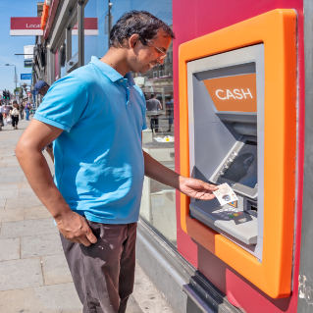
If this proposal happens do you think there will be enough access to cash services where you live for:
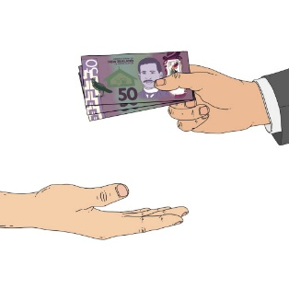
people
businesses?

Tick the box that is right for you.

there will be not enough access to cash services

there will be about the right amount of access to cash services

there will be too much access to cash services

I do not know.

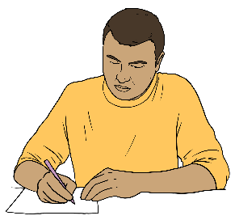
Write in the box below why you gave the answer on the previous page.

If this proposal goes ahead do you think there will be enough access to cash services in all of Aotearoa New Zealand for:
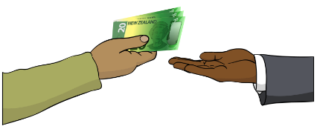
people
businesses?

Tick the box that is right for you.

there will be not enough access to cash services

there will be about the right amount of access to cash services

there will be too much access to cash services

I do not know.

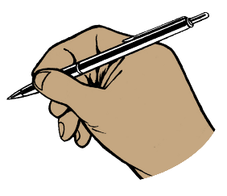
Write in the box below why you gave the answer on the previous page.

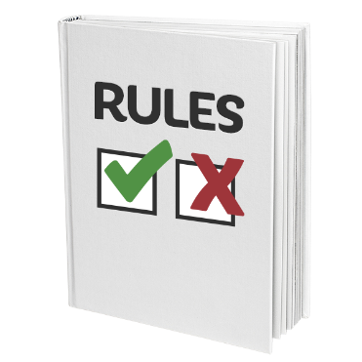
Should there be different rules for some:
rural / out of town areas
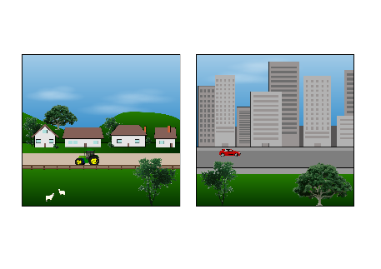
towns
parts of a city?

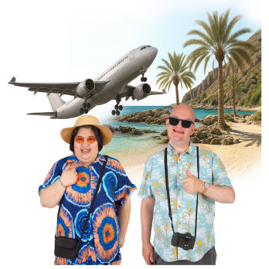
For example places like Queenstown could have more cash services because a lot of tourists go there.

Tick the box that is right for you.

yes

no

I do not know.

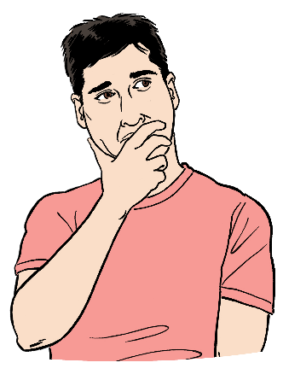
What things should we think about when deciding if a place needs different cash services than the proposed standard?

Tick all the boxes that are right for you.

how many people live in the area

how many businesses there are in the community

how far it is to the next town with cash services

how important tourism is to the area

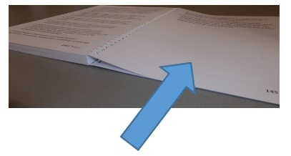
There are more options on the next page.

What other things should we think about when deciding if a place needs different cash services than the proposed standard?

Tick all the boxes that are right for you.

the kinds of people who live in the community

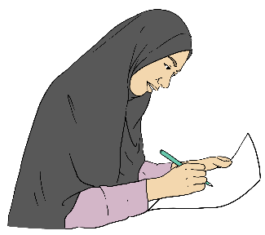
how much it costs banks to have cash services there

something else – write what this is in the box below.

Other feedback

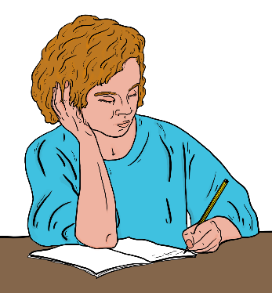
Is there anything else you would like to say about cash services in Aotearoa New Zealand?

Write what this is in the box below.

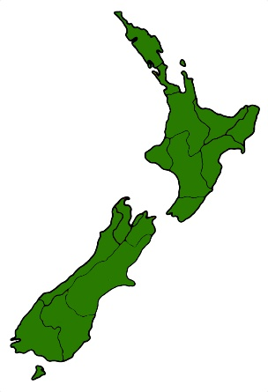
Where do you live at the moment?

Tick the box that is right for you.

rural area near other people

rural area that is not near other people

urban area in a town

urban area in a city

none of these

I do not want to answer.

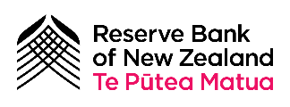
This information has been written by the Reserve Bank of New Zealand – Te Pūtea Matua.

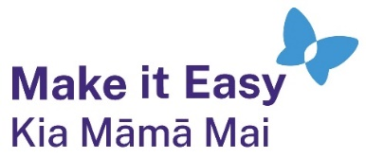
It has been translated into Easy Read by the Make it Easy Kia Māmā Mai service of People First New Zealand Ngā Tāngata Tuatahi.
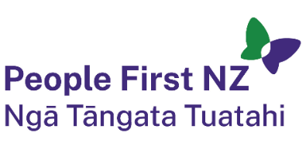
The ideas in this document are not the ideas of People First New Zealand Ngā Tāngata Tuatahi.

All images used in this Easy Read document are subject to copyright rules and cannot be used without permission.

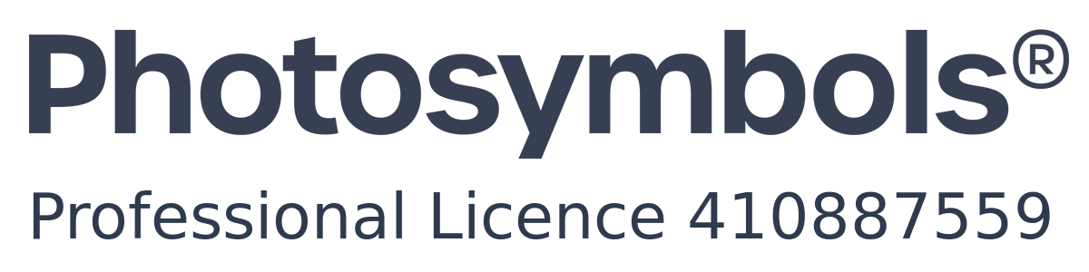
Make it Easy uses images from:

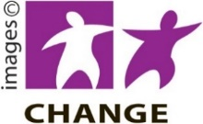
- Photosymbols

- Change Images



- Huriana Kopeke-Te Aho

- SGC Image Works

- T Wood


- Studio Rebeko

- Inga Kramer.
- Reserve Bank of New Zealand.

